BUNKER
TALK
Corps

  - Spears Detachment #066 Pensacola, FL
Founded January 19th, 1984 by William D. Carter
God Country
MEETING
Date/Time:
2nd Tuesday of each month at 1900
Location:
Florida National Guard Armory
8790 Grow Dr. in the Ellison Park Industrial

Contact Us:
J.R. Spears Det. 066 Marine Corps League
P.O. Box 3491 Milton, FL 32572 850-637-8385 Website:
http://pensacolamcleague.com

December 2016

My Engagement
By
Maggie Rogers
As some of you know that I got engaged. Well at a meeting for the Christmas party, I announced that I will be getting the married and moving to Asheville, North Carolina. You know how funny the Commandant can be. He ask who gave the permission for me to be married. So I told my fiancé and he wrote this letter for the Commandant and the League. Commandant and the league you can respond to me at teachothers@aol.com or Mark Stiemke at harleywings1958@yahoo.com
To the Commandant of the Marine Corps League in Pensacola, Florida:
Dear sir it has come to my attention that I must introduce myself to you sir, Commandant Holzworth my name is Mark Steimke. I am a Marine from Asheville, NC and I am here writing you this letter to ask permission to marry one Maggie Rogers, one of the finest Marines you have ever known.
I hope that you grant this union and blessing upon us or I will have to answer to my seven year old son, who adores her and wants her to be in our family. xxxx xxxxxx
I, this devil dog, must get a yes from you.
Thank you for your service, Semper Fi, and God's speed to all and OOHRAH Devil Dog, sir.
Thank you for your consideration and thank you Marine Corps league.
Sincerely Mark Steimke

M
Mark Stiemke
Devil Dog for life .

Marine Corps Birthday

The Marine Corps' birthday is a day of pride and respect, and its celebration is one of the most revered traditions in the Corps. Each year, on November 10th, Marines around the world celebrate what they see as their "second" birthday, the day the United States Marine Corps was born.
The tradition runs deep. For years, Marines have been telling each other "Happy Birthday" on November 10th and attending Marine Corps Birthday Balls in cities across the globe. Each year, the Commandant of the Corps reads his "Birthday Message" to all Marines, and they "...reflect upon the legacy of [the] Corps and upon the awesome responsibilities lying ahead." (Warrior Culture of the U.S. Marines by Marion F. Sturkey).
We always find a way to celebrate the Marine Corps Birthday whether it is in the field or lavishly like the Superdome or the New World Landing.

The 1st - 241st Birthday was done at the New World Landing put on by on by our Marine Corps League, Corporal J. R. Spears, Detachment 066. Doc Ed and his wife Mary did a fantastic job in putting it together. We had 2/5 Marines as our special guest. In attendance, we had about 300 Marines and Navy active and veterans. This as an epic event that we have not done before. You saw the love and the laughter our Marines.
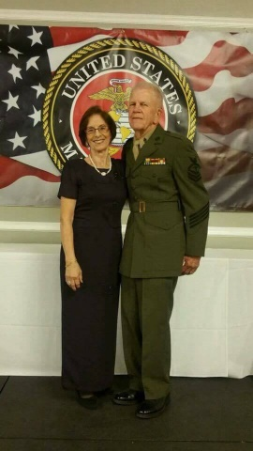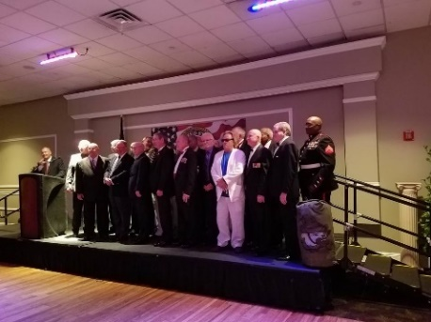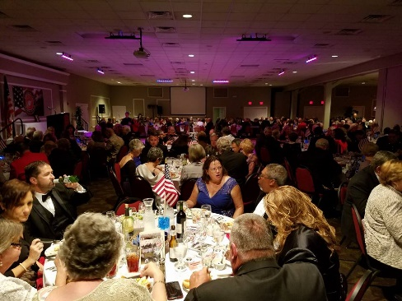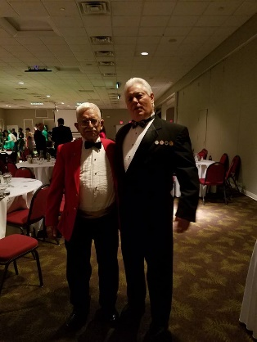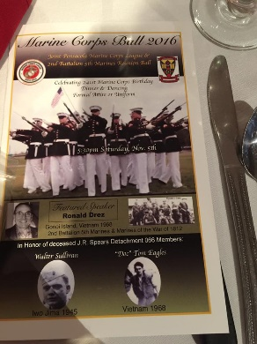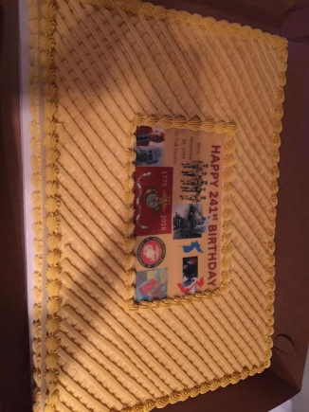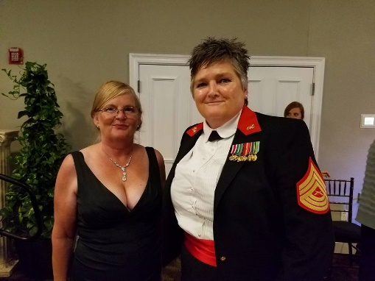
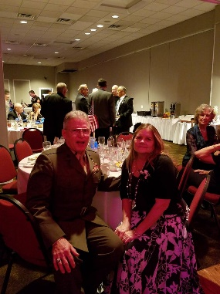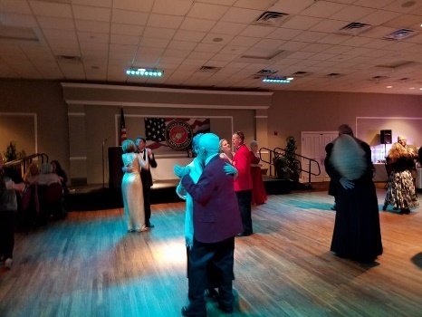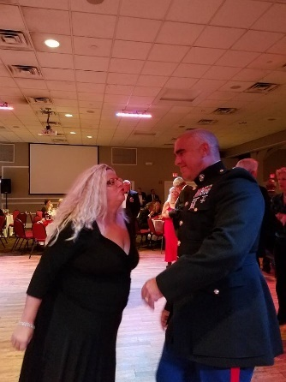
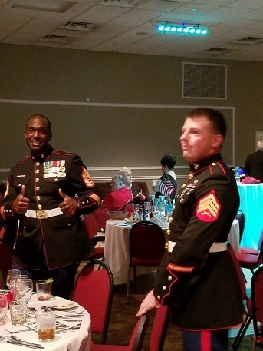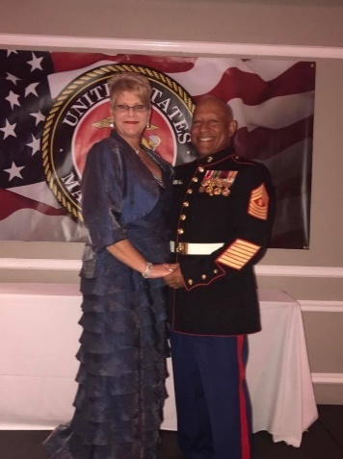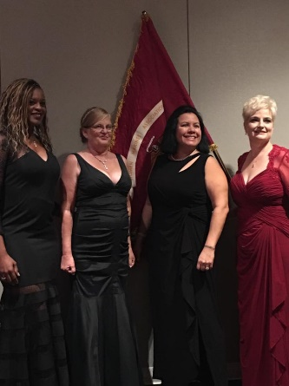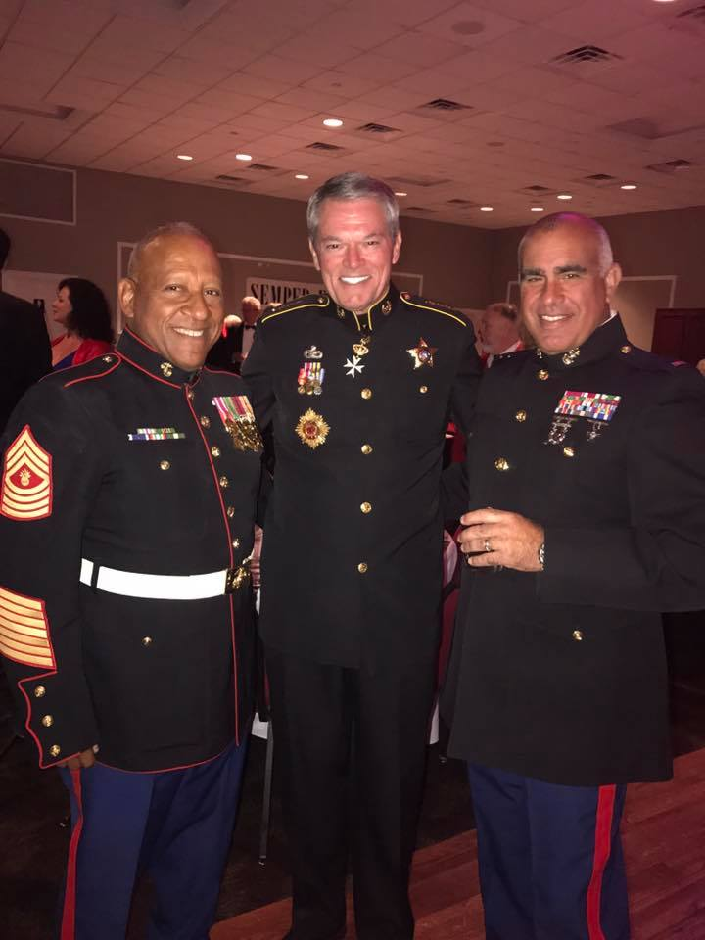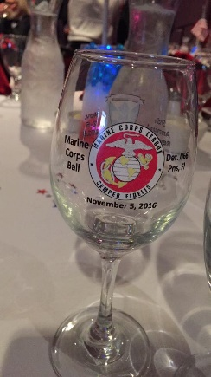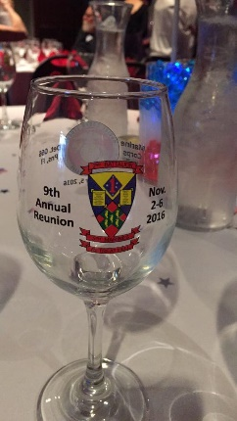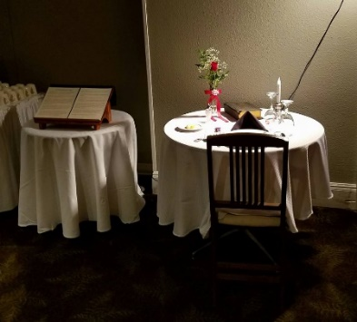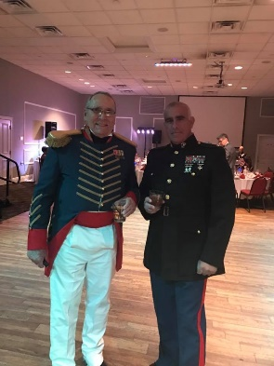

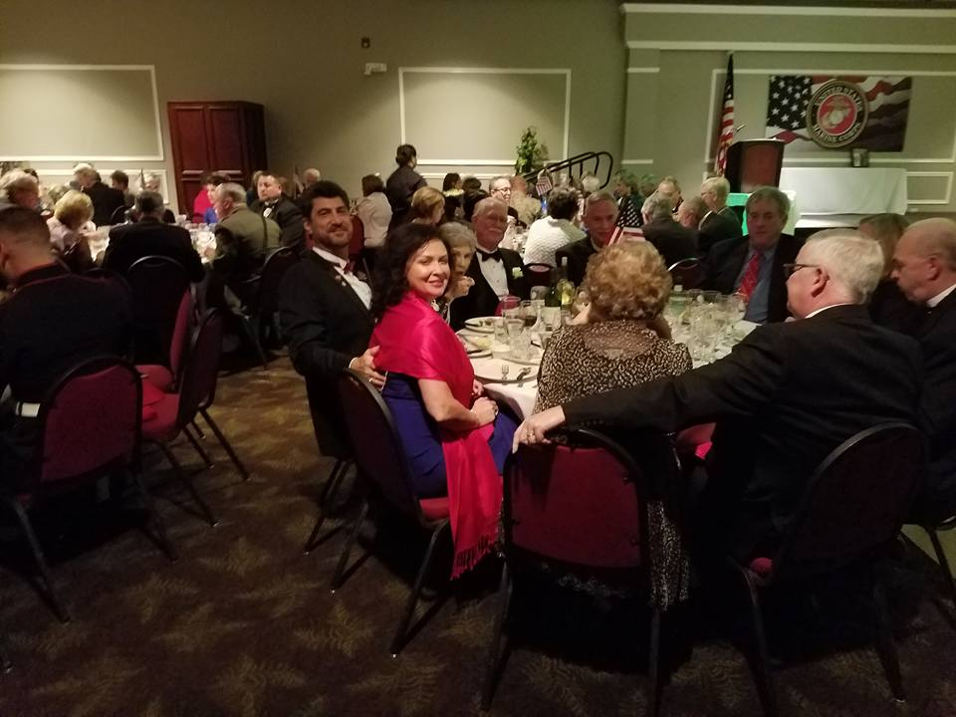

2nd – Marine Corps Birthday at Cookies and the birthplace of Marine Corps. My travelling partner, Jenny and I went to Philly to the birthplace of the Marine Corps. The Marines – veterans and active duty celebrate at Cookies Tavern on the 10th of November. Cookies had a couple blocks blocked off for the celebration. We went to the Tun Tavern sign and got selected to see the original Pentagon and the war room. If you have not been there you need to go.
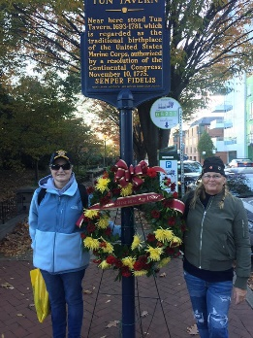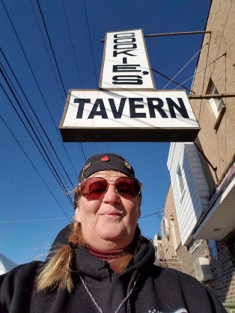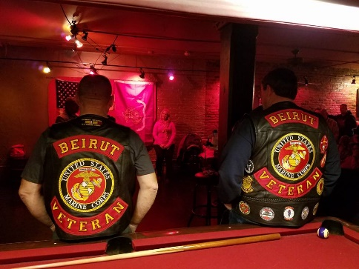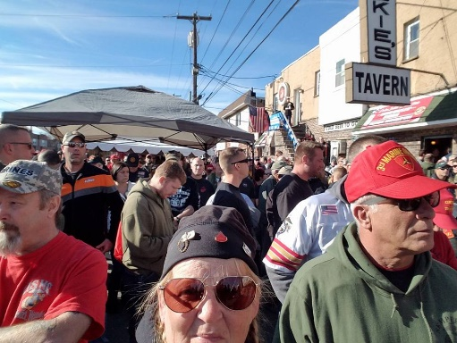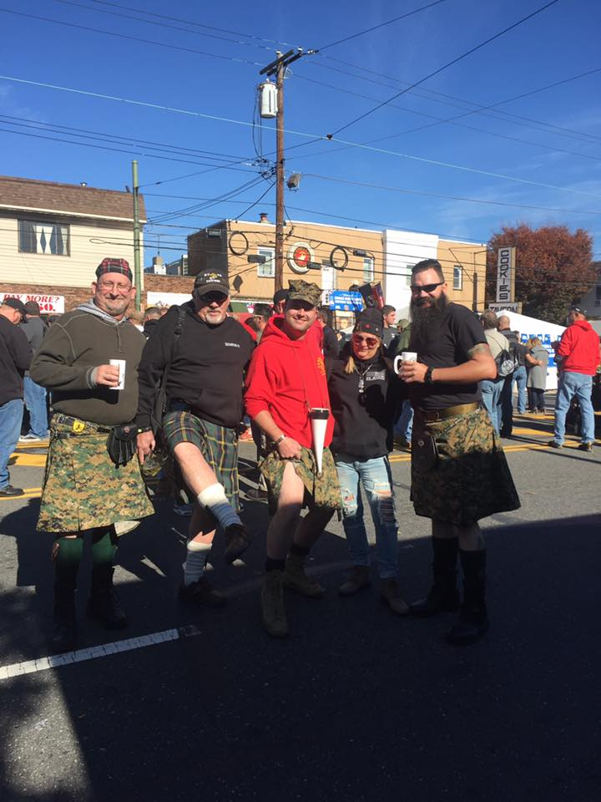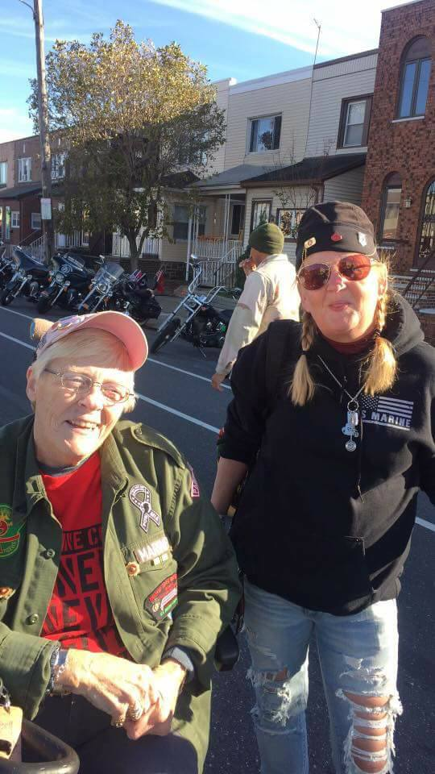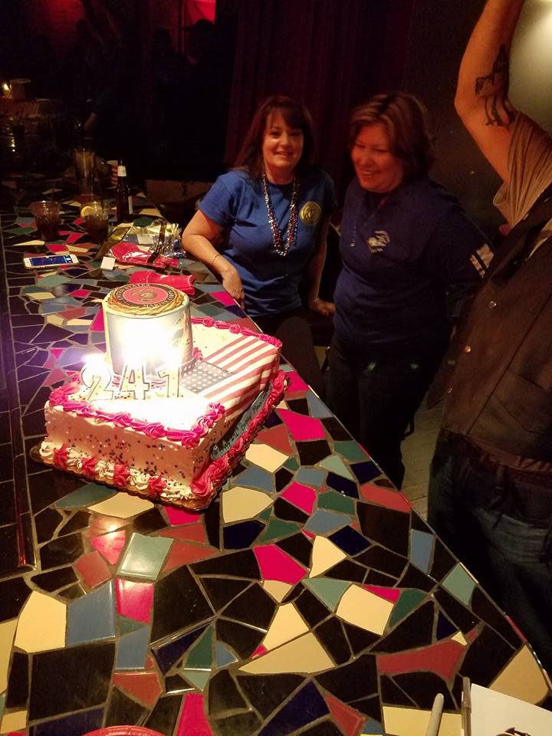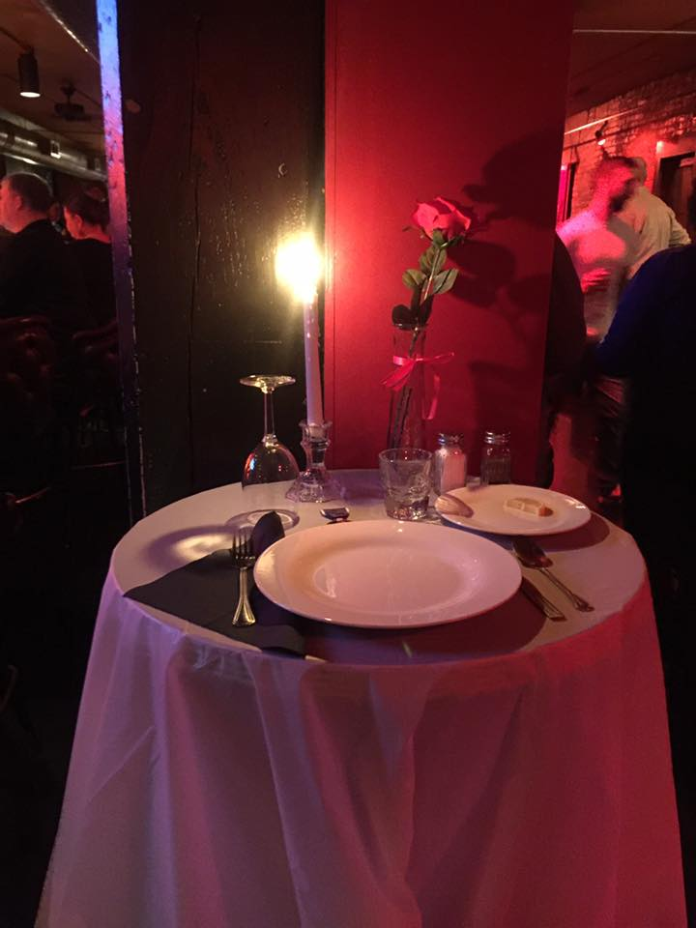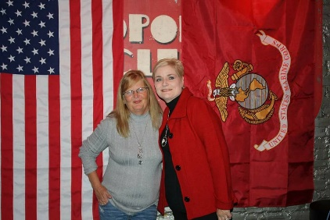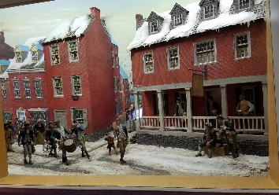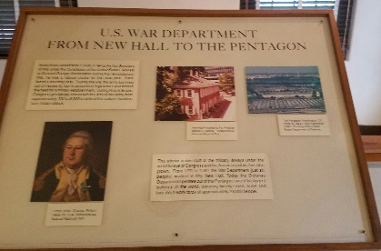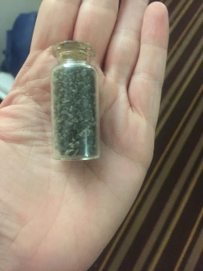

3rd – Marine Corps Birthday Ball at the Superdome. This ball was very lavish on the Saints Football field. The guest speaker was 35th Commandant of the Marine Corps General Amos, owner of the Saints football team and President of WMA an active duty and veterans of all rank. Approximately 18,000 in attendance. We had to wait until our Birthday gift because it was a Kbar. 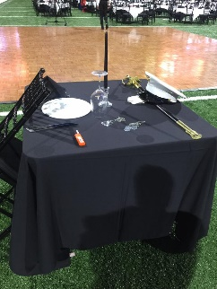 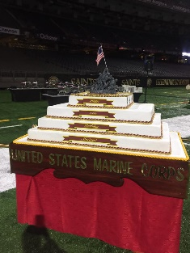 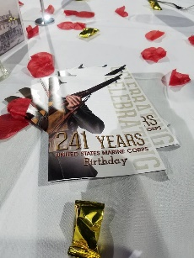 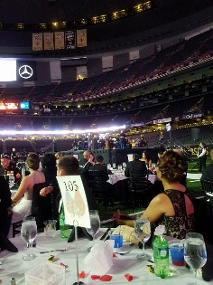 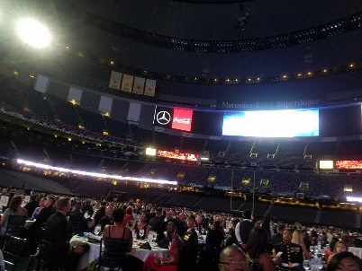 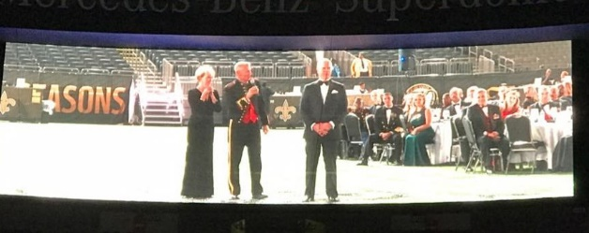 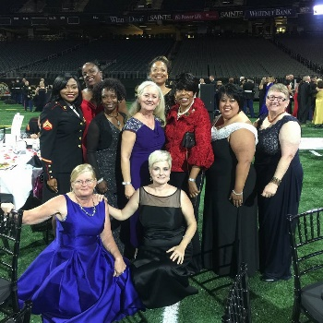 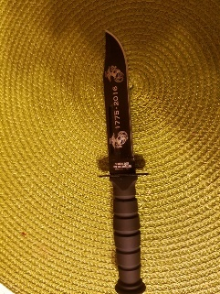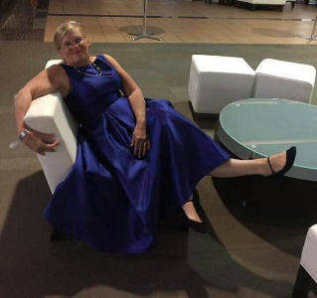

A Message from the Commandant

Marine Corps Leaguers/Warriors of Detachment 66:

It has been a great year of Espirit de Corps and contribution to our Greater Pensacola community. Our "Award Winning" Heroes Among Us Speaker Series has kicked off the 4th season in grand style with record crowds and world class speakers-true heroes of our area and nation! We continue to meet the requests of local Veteran's who are in need with grants from the Veterans in Need Fund; our Service Division headed up by Doc Dodge has been doing outstanding work in supporting Veterans with their medical needs and VA claims. Recently, Tom Fitzgerald authored a point paper to MCL National to incorporate the Service Division into the Table of Organization of all MCL Detachments. Semper Fi Run on 10 September was a huge success with $20,000 being raised for local children's charities.

As we move into the Fall, let us all continue to support the great work of the League in the community as we finish our HAU season this year with two more great events in September and October. In addition, our MCL Marine Ball Celebration on 5 November with "H" Company 2/5 Vietnam reunion is sure to be a magnificent event. Lastly, 22 Oct is a Flagship event with the 16th Annual Car Show at Five Flags Speedway-please put this on your calendar.

Proud to be your Commandant-happy to be with Marines, Sailors, Soldiers, Airmen contributing to our community. I am proud to report our Detachment has soared to over 130 members from 77 a year ago and we are seeing greater numbers and veterans joining every meeting. Thanks to all for your servant's hearts.

Semper Fidelis,

Caveman

Commandant J. R. Spears Detachment, Pensacola, Florida

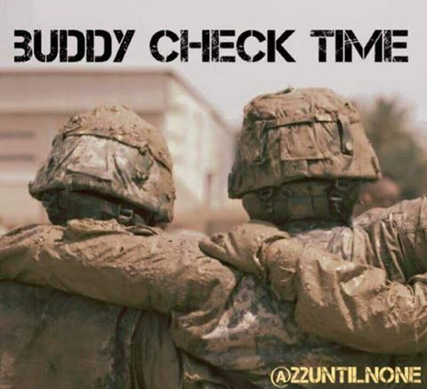
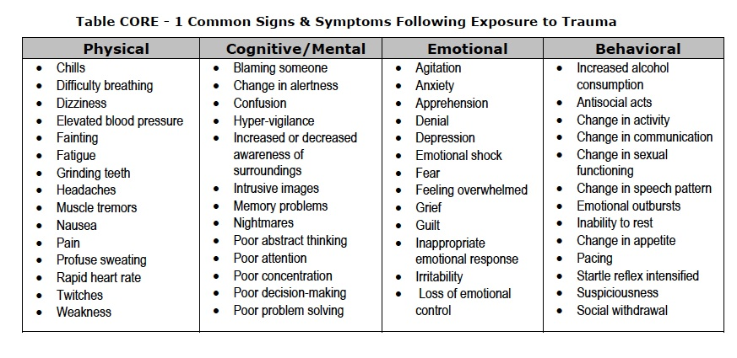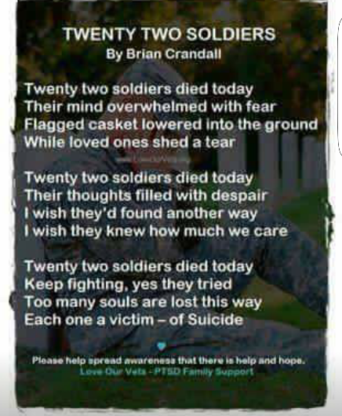

(This is real problem. We have 22 veterans that commit suicide a day. We need to do our best to help prevent one in becoming 1 of the 22. Call, text or message then on Facebook. If you one that does suffer from PTSD like I do talk to someone it helps whether it is a friend or therapist.)
Maggie Rogers

Commandant
Chris Holzworth holzworths@bellsouth.net
850-463-2494

Senior Vice Commandant Robert Fernandez w5.usmc@gmail.com
850-995-7014

Junior Vice Commandant
Chuck Miller
avavball@aol.com
850-712-8380

Judge Advocate
Fitz

850-380-3478

Adjutant/Newsletter
Maggie Rogers teachothers@aol.com
562-964-8702

Paymaster
Ben Sandoval bensand48@hotmail.com 850-572-0554

Admin Officer (S-1)
JoAnn Lee
joannlee1983@gmail.com
850-7917089

Logistics Officer (S-4)
Kaci Sloan
mrsalismom@gmail.com
850-400-0165

Ops Officer (S-3)
Kenneth Morrow
good2015year@gmail.com
850-288-1097

Sgt. At Arms

Hiram Johnson

850-453-4521

Chaplain/Visitation Chairperson
William Broach
jet727@gulfeg.com
251-961-7272

Public Affairs Officer
Ed Rouse erousecpa@bellsouth.net
850-393-3507

Webmaster (S-6)
Ralph Koeniger
ralphkoeniger@att.net
850-725-0034

Yearly Dues

For members who pay their dues annually the dues are now $45 for renewals and $52 for new members. The
$52 includes the cost of the name tag.

New Members

There is a change in procedure for new members in that they will receive a membership packet when they provide a copy of their DD214. Then they will be sworn in at the following monthly meeting.

Life Membership Dues
AGE GROUP As of JAN. 2014 0 - 35 $500
36 - 50 $400
51 - 64 $300
65 - Over $200

PSD ID Card Processing Hours and Information
ID CARDS and DEERS ISSUES are handled between 0730 HRS and 1600 HRS, Monday through Friday.
The Customer Line may be tagged prior to 1600 hrs to accommodate the volume of customers.

Ship’s Store

Members wishing to purchase MCL merchandise, including covers, may do so by contacting the Marine Corps League Ship’s Store at 800-625-1775 or visit www.mcleague.org.

Wreaths Across America
Wreaths Across America accepts donations year around. Visit their website
http://www.wreaths-across-america.org/ for further information and consider making a donation to help them continue this outstanding program. The Young Marines are selling wreaths locally for $15 each.

If you require an ID card, you must have 2 forms of identification. In addition, military dependents must be accompanied by the sponsor or have Power of Attorney for the sponsor AND a DD1172 signed by the sponsor and an ID Verification Official. Please bring any required documentation needed for the requested service.

To assure that your ID CARD and DEERS issues are handled in a timely manner, it is suggested that you make an appointment at the following website:

http://appointments.cac.navy.mil Please contact our office if you have questions.
PSD Pensacola, Bldg 68o 421 Saufley Street, Suite B 850-452-3617

Businesses supporting the J.R. Spears Detachment of
the Marine Corps League
Detachment Member Owned Businesses
Steve Sanderson Automotive Alternative 6426 Pensacola Blvd.
Pensacola, FL 32505
850-857-1222

Earl Wright. Alarm Direct
850-776-7873
Smart Security and Surveillance Solutions

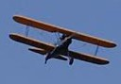
Roy M. Kinsey,Jr. Attorney at Law
438 E. Government St. Pensacola, Florida 32507
850-434-5267

Tom Armstrong More Ink For Less 120 Chief’s Way, Suite 1
Pensacola, FL 32507
850-455-1234

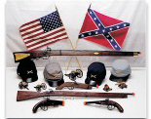
Del Lozano T&D Gallery of Gifts Pea Ridge Flea Market
5186 Hwy 90 Booth #33 & 34
850-450-7825

Ed Rouse

Ducker & Company
6825 Oak Street
Milton, FL 32570-0889
850-623-3250

Frenchy LaFountaine Ultra Marine Productions
9810 Indian Ford Rd. Milton, FL 32570
850-957-9069

Rhett Smith, P.A. Attorney at Law
714 N. Spring Street Pensacola, Florida 32501
850-438-1220

Community Owned Businesses

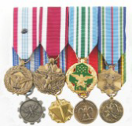
Medals to Honor, Inc. “Honoring Those Who Serve” www.MedalsToHonor.com
910-326-4275

BK Inflatables, Inc.
Let Us Inflate Your Next Party
850-324-1812

Hirst Transmission Specialist
8415 N. Palafox St. Ensley, FL 32534
850-478-3395

Petrick Custom Cabinets
Free Estimates 850-492-5480

Cantonment Building Materials & Hardware
990 Hwy 29 North Cantonment, FL 32533 850-968-6639

