BUNKER
TALK
Corps

  - Spears Detachment #066 Pensacola, FL
Founded January 19th, 1984 by William D. Carter
God Country
MEETING
Date/Time:
2nd Tuesday of each month at 1900
Location:
Florida National Guard Armory
8790 Grow Dr. in the Ellison Park Industrial

Contact Us:
J.R. Spears Det. 066 Marine Corps League
P.O. Box 3491 Milton, FL 32572 850-637-8385 Website:
http://pensacolamcleague.com

November 2016

My Temporary Roommate
By
Maggie Rogers
My vistor Seveieng Suparat, my temporary roommate, from the Hmongs visit. She is Laotaian and fought for Special Unit Guerilla (SUG) who recused shot down pilots. Seveieng joined at the age of 13. In 1975 she was captured and was a POW for 9 years. When she escaped, she had one (1) child and 7 months pregnant. It took her several days to travel and hide from North Vietnam to Thailand. In about a year she was able to immigrant to Minnesota. She and others have gone through a lot mental and physical without the benefits that our vets get. They fought for us under the umbrella of the CIA. We been told for years that we were not in Laos.
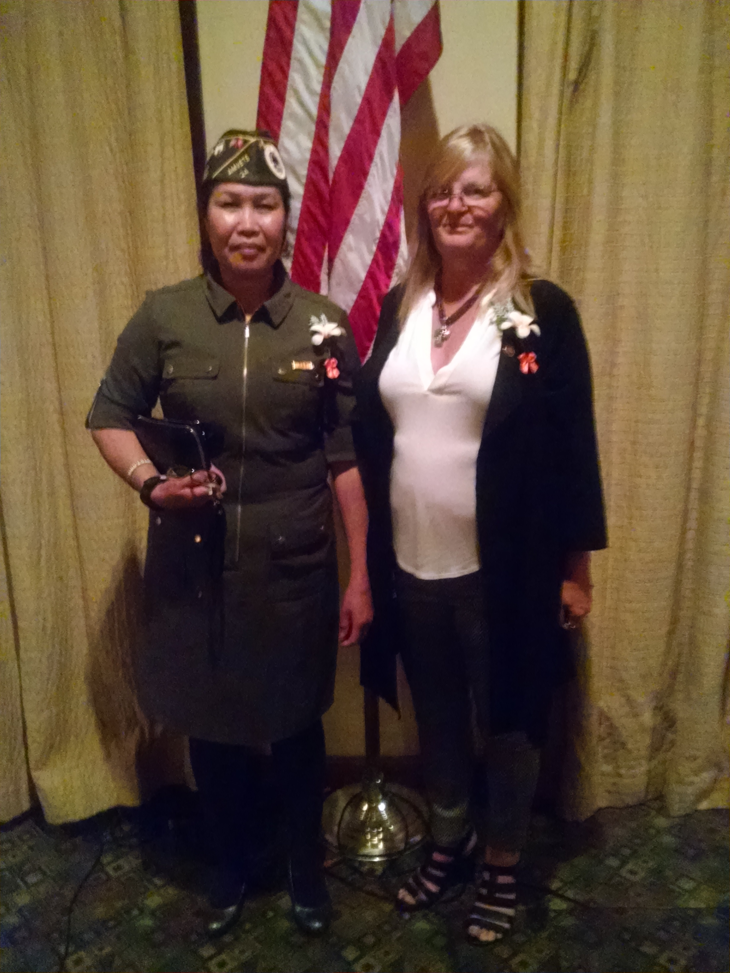

HAU Event with Gen Secord and Hmongs and Laotians and Visit
Thank you to E Rouse who organized this amazing and eye-opening experience. Thank you to Ralph Koeniger, Ben Sandoval, Doe Roe, Ed Schaier, Frenchie, and Maggie Rogers in picking up the visitors, housing them, and taking them around town and dropping them off. Our visitors mention that they had a great time hear and some of us have made lifelong friends. Our guest visited American Legion #240, Naval Aviation Museum, and a restaurant hat we renamed Say Yes. Inside joke, you had to be there
The HAU event was the biggest turnout that we had between the Hmongs and Laotians, who came to the event and our community.
The speakers talk about their involvement in Laos, which was been said for years that we were not there, but we know better. What was heart wrenching was the stories that were told from the Hmongs and Laotians from the age they joined to being POWs. They fought for us under the CIA umbrella in rescuing down pilots that were shot down in Laos and received no benefits from our Government.
Some have been ill and getting up in age. They suffer like our veterans do 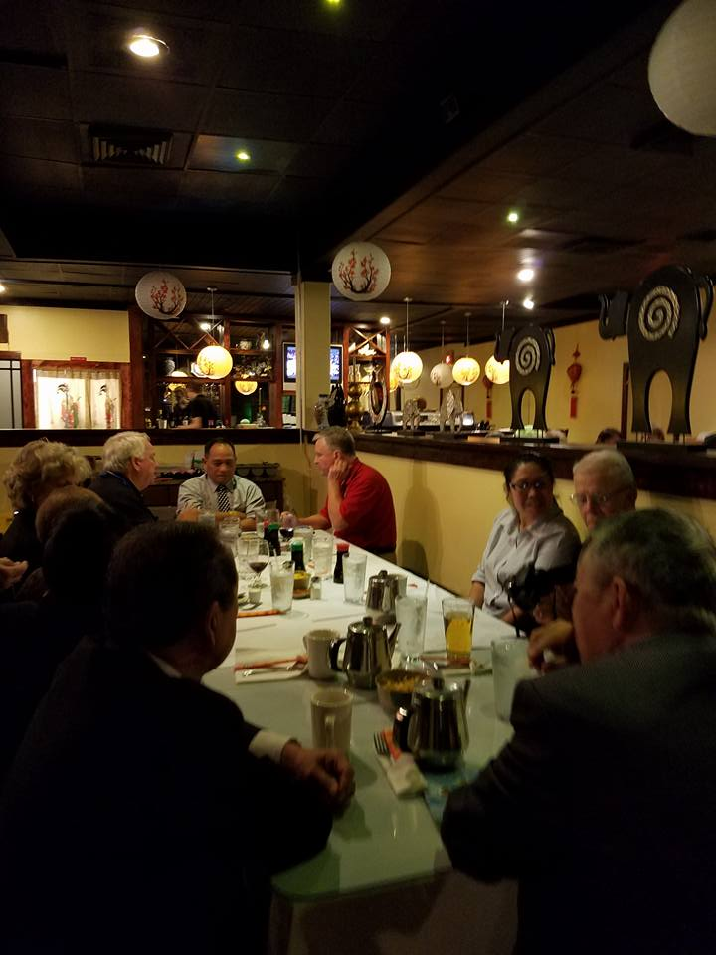 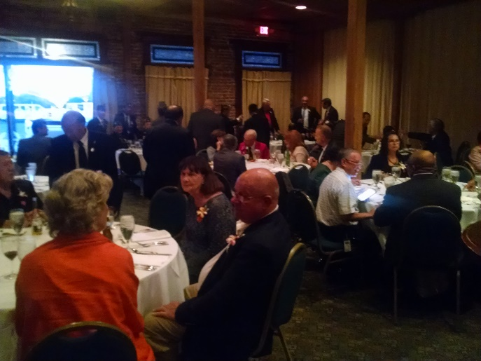 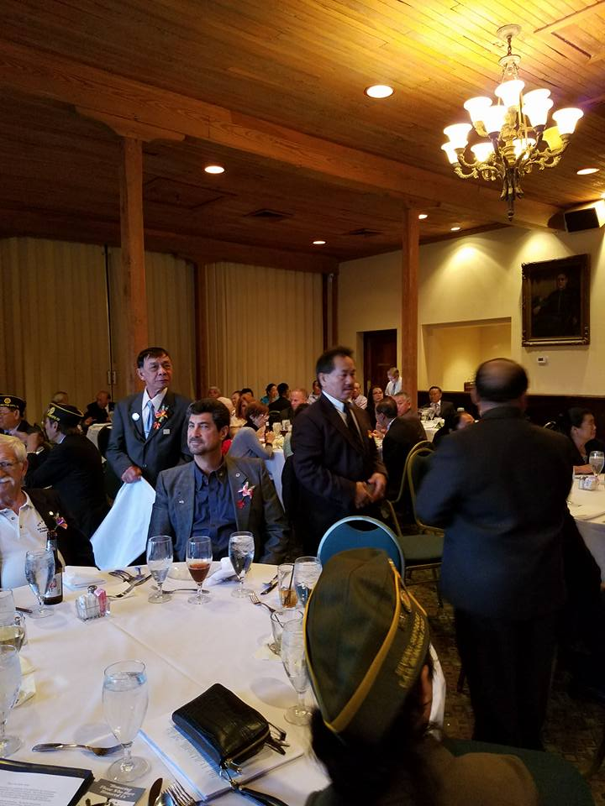 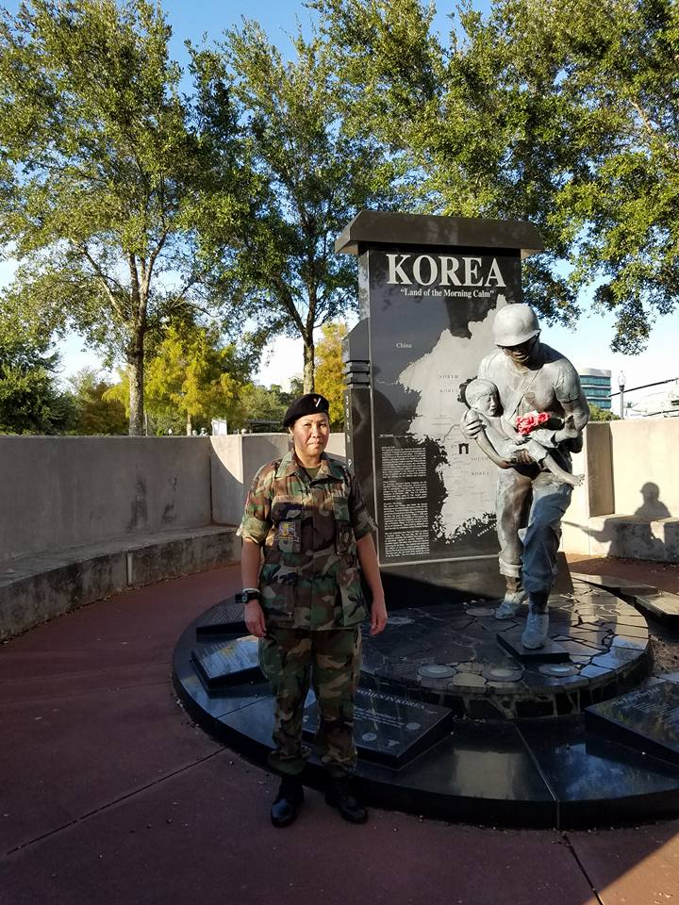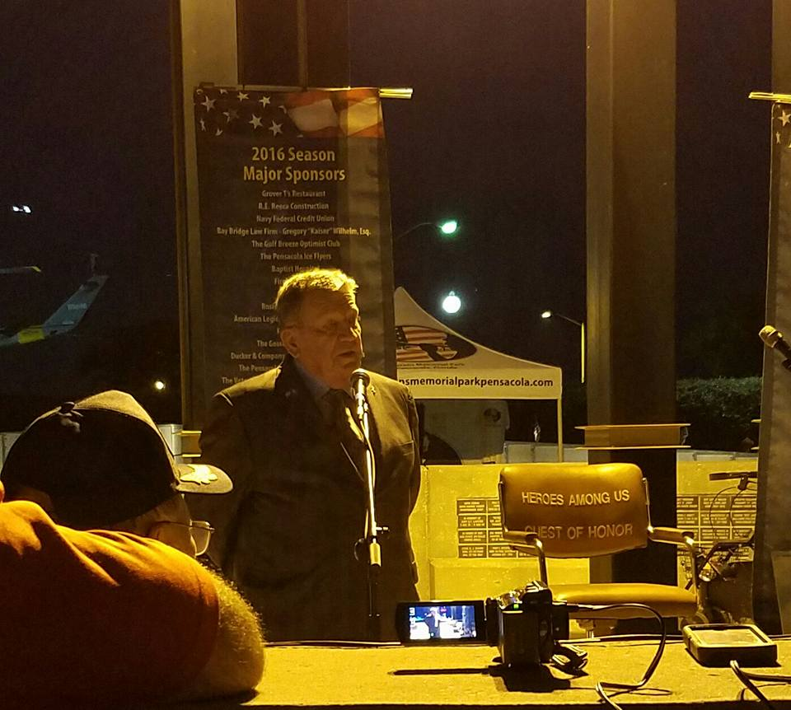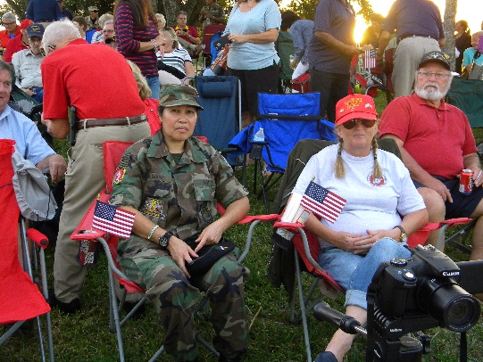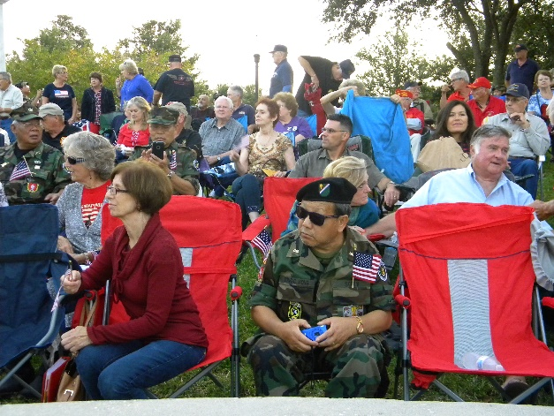 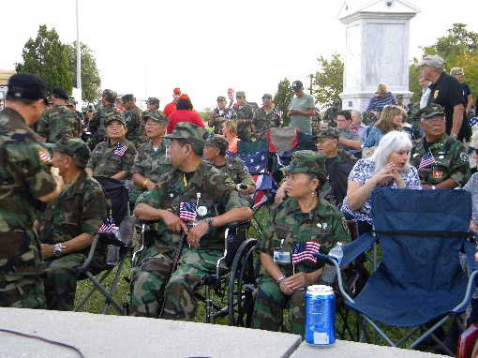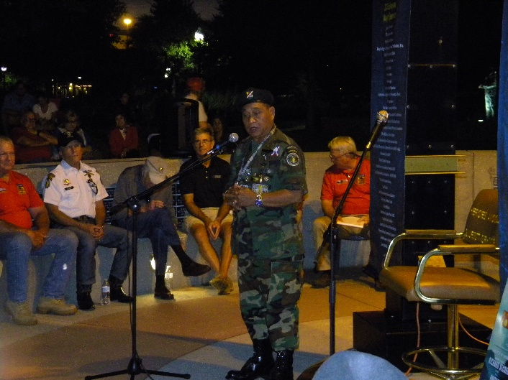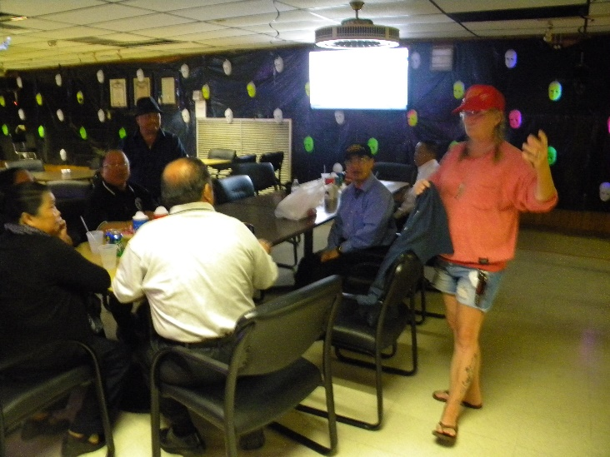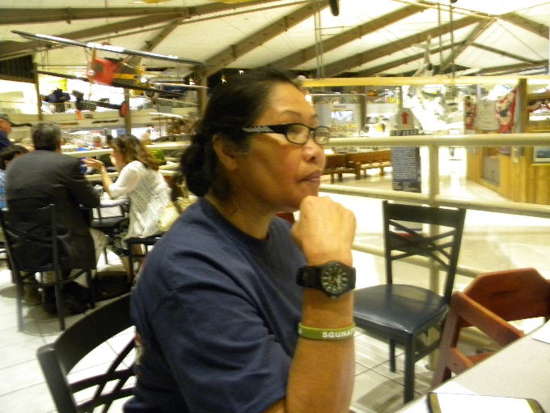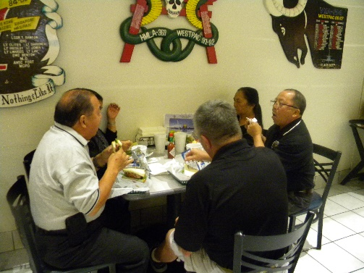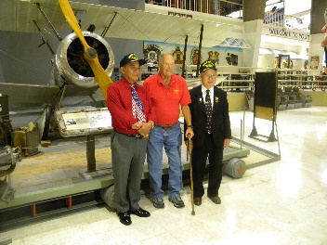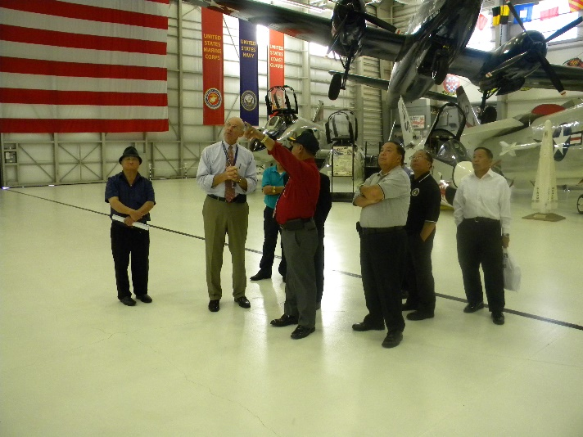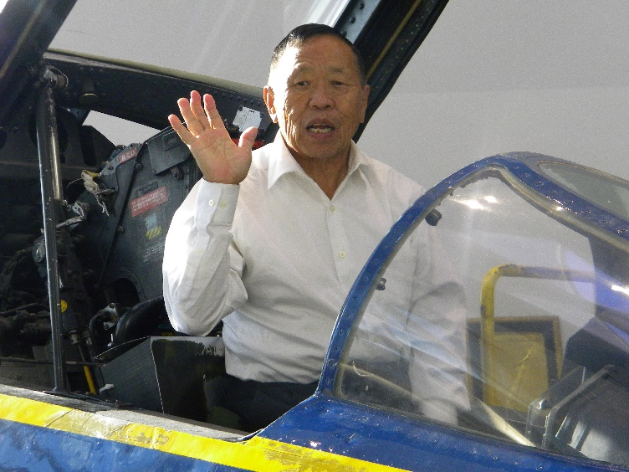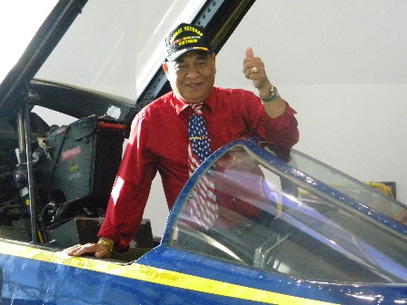

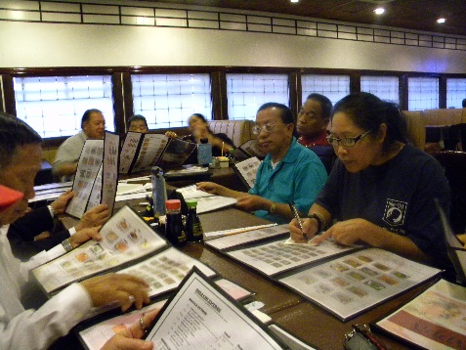

Car Show
The car show was outstanding. We had over 50 cars that showed up. I want to thank everybody that helped in getting sponsors, vendors and volunteers. Bob Rivera and Major Morrow look sharp in their dress blues.
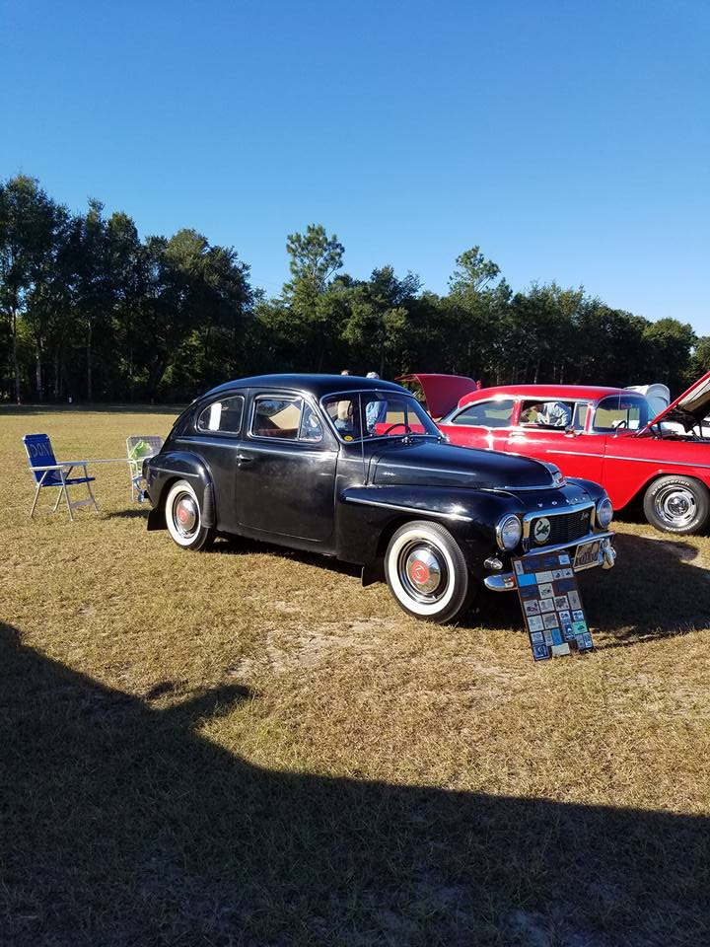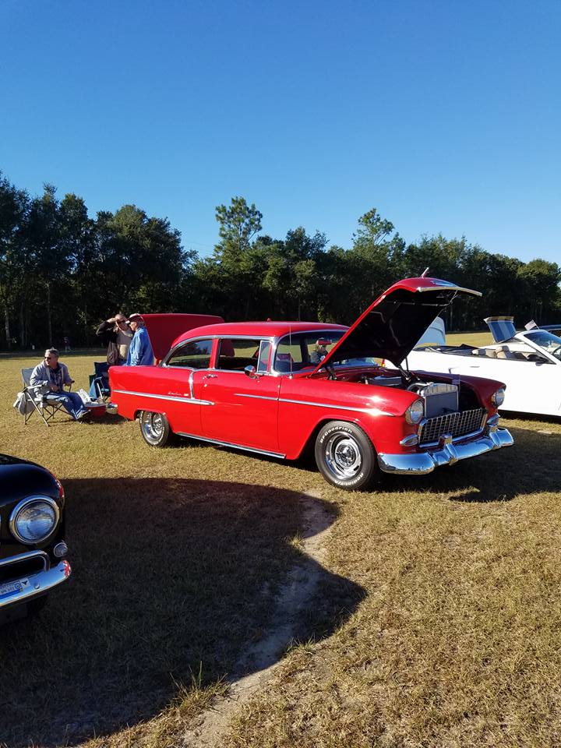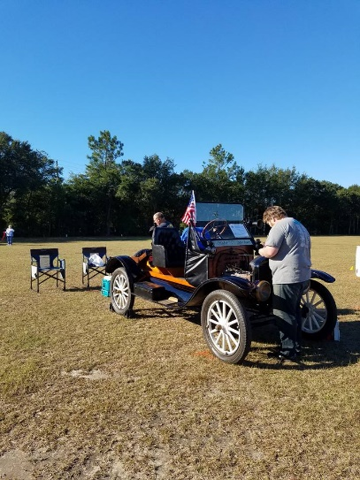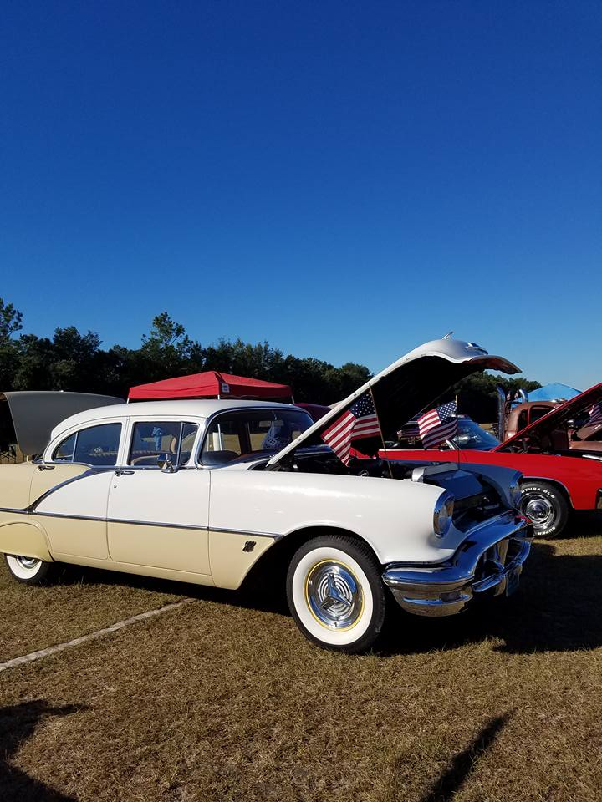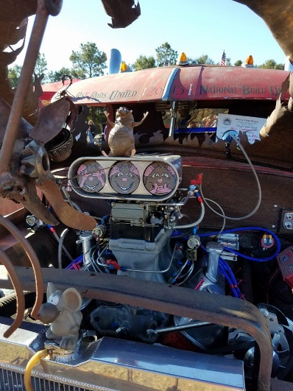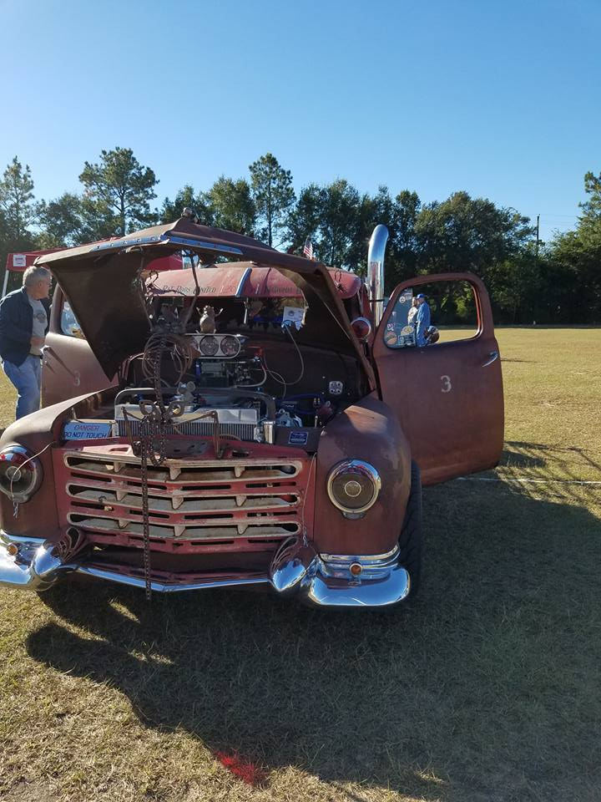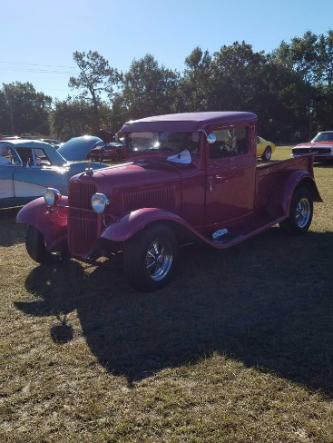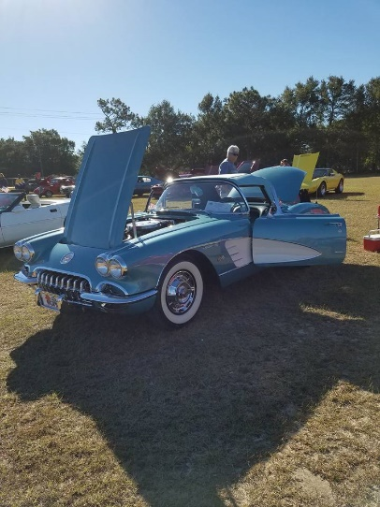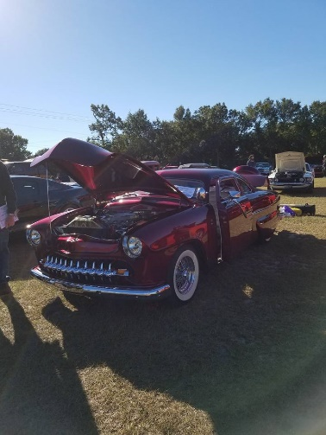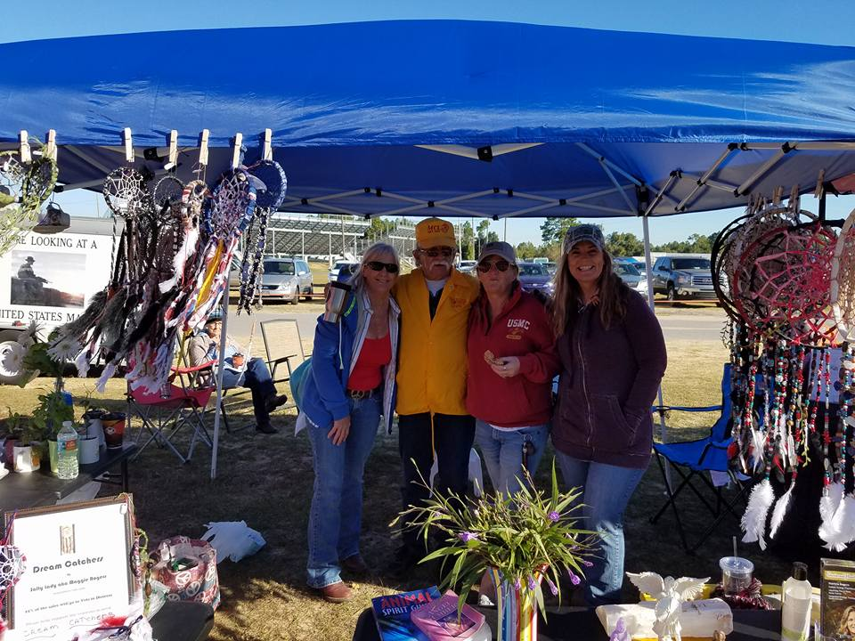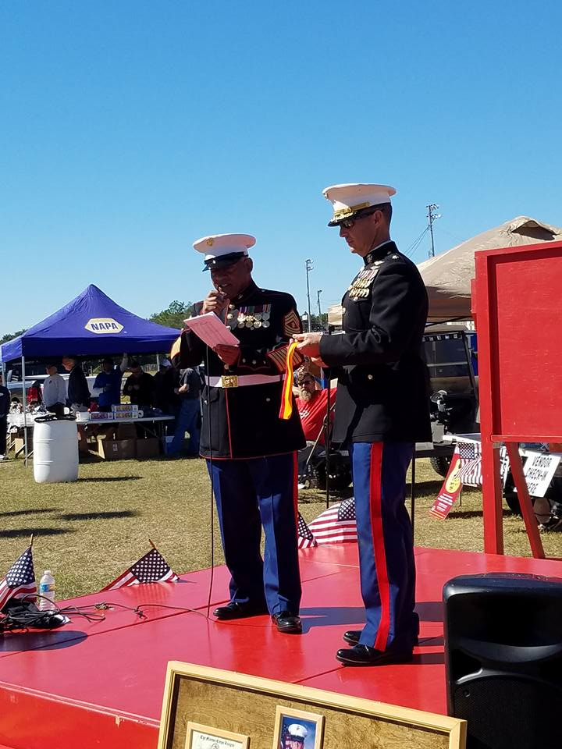

Event pays tribute to Hmongs' role in Vietnam War
Melissa Nelson Gabriel , mnelsongab@pnj.com 11:03 a.m. CDT October 27, 2016
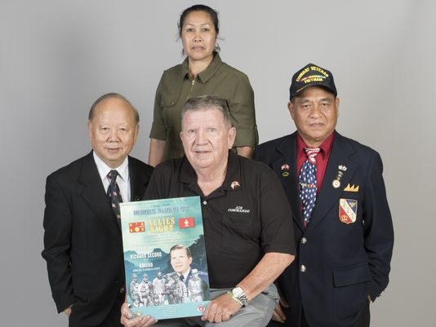
Clockwise from left: Brig. Gen. Hauly Moua, Sergeant Maj. Sevieng Suparat, Maj. Sar Phouthasack, and Ret. Air Force Gen. Richard Secord on Wednesday, October 26, 2016.(Photo: Gregg Pachkowski/gregg@pnj.com)Buy Photo
A former CIA operative and Lao soldiers will share stories of bravery and sacrifice in a secret war fought to support American forces in Vietnam on Thursday night as part of the Heroes Among Us speaker series.
Retired Air Force Gen. Richard Secord, who was assigned to the CIA in Laos from 1966 to 1969, will be joined by former high-ranking Royal Lao Army soldiers during the final 2016 installment of the popular outdoor speaker series at Veterans Memorial Park. The monthly presentations are sponsored by the Pensacola Marine Corps League and draw on the war stories of area veterans to raise money for military families.
Secord and the Lao soldiers hope to bring attention to the covert war to control the flow of troops, armaments and supplies along the Ho Chi Minh trail on the border between Laos and Vietnam. An estimated 35,000 Lao soldiers died fighting for American interests in the region.
Secord was assigned to the CIA in Laos at a time when the covert American presence in the country ballooned. Under the terms of the Geneva Accord, signed in 1962, the U.S. and North Vietnam agreed not to have troops in Laos.
"The North Vietnamese said they were not there, we said we were not there. There was a lot going on in a place where nobody was supposed to be," Secord said.
The war ultimately devastated the Hmong people, a Lao ethnic group that provided many of the soldiers. Tens of thousands of Hmong and other Lao people died during the war and many others languished in reintegration camps for years after the country fell to communist insurgents in 1975.
"Looking back on it, what bothers me is that there is not much knowledge about any of it now. They say Korea was the forgotten war, but we have forgotten so much of what happen in Southeast Asia," Secord said.
Maj. Sar Phouthasack served in a Special Guerrilla Unit (SGU) of the Lao Army. Phouthasack recalled scouting operations to locate North Vietnamese convoys on the Ho Chi Minh trail and call in airstrikes.
"I called in signals for American pilots to direct the bombs. If we hadn't done that, I don't know how many more Americans would have died in Vietnam," he said.

By attacking the North Vietnamese in Laos, the SGUs kept an untold number of troops and armaments out of Vietnam.
Phouthasack also recalled an operation in which he parachuted into the deep jungle to make contact with a special operations unit that was lost behind enemy lines. Phouthasack found the men and spent three months working as a combat radio technician before making his way through the jungle back to safety.
The SGU units are credited with rescuing countless American pilots shot down during the war.
Brig. Gen. Hauly C. Moua worked under the direction of Gen. Vang Pao, commander of the Royal Lao Army. Moua trained as a medic, radio operator and paratrooper before working with American forces at the operational headquarters.
"In my life then, we were very close with the Americans. We worked very closely on everything," he said.
Moua was the last officer to leave the headquarters after the communist takeover in 1975. He fled to Thailand on foot and moved to the United States in 1980. The former general remains a leader of his Hmong people in exile from his home in Minnesota, advocating for the SGU soldiers to receive military benefits and honors from the U.S. government.
Moua has lobbied Congressional leaders to pass a bill that would provide health care services, military pensions and other benefits, including military burials, to former Lao soldiers. He said the issue is urgent because the former Lao soldiers are now in their 70s and 80s and in poor health and living in poverty.
"The United States recruited, trained, supervised, led and paid Lao/Hmong soldiers to fight the (North Vietnamese) in Laos and the Ho Chi Minh trail for the benefit of the United State's Armed Forces. Surely this falls into the category of U.S. Military. During this time from 1961 to 1978 and for several years thereafter, the Lao/Hmong lost over 35,000 dead and many, many more were wounded," Moua wrote in a letter seeking recognition of the soldiers.
Secord and others who worked with the Lao soldiers have pushed for them to receive military benefits.
The Lao soldiers are not asking for much considering what they sacrificed to fight on behalf of the Americans, Secord said.
Sevieng Suparat was recruited as a nurse to tend to wounded SGU soldiers when she was just 13. Suparat also fought alongside the men at times. After the war, Suparat spent nine years as a prisoner in a reintegration camp. She eventually escaped to Thailand, never knowing what became of many of her family members. She later moved to Minnesota.
More than 30 other former Lao soldiers plan to attend Thursday night's event. Many of them have traveled from other states.
The Lao/Hmong soldiers are proud of their history and want to share their story, Moua said.
"I am very happy to see Gen. Secord here," he said. "We are connected because of our past and I ask him and others to please remember what happened," he said.
Secord, who went on to serve in the Department of Defense and worked on U.S. operations inside Iran, said the U.S. government has made some of the same mistakes it made in the Vietnam era dealing with the people of Iraq and Afghanistan.
"We don't seem to learn from our history, our mistakes," he said. "We make the same mistakes over and over

A Message from the Commandant

Marine Corps Leaguers/Warriors of Detachment 66:

It has been a great year of Espirit de Corps and contribution to our Greater Pensacola community. Our "Award Winning" Heroes Among Us Speaker Series has kicked off the 4th season in grand style with record crowds and world class speakers-true heroes of our area and nation! We continue to meet the requests of local Veteran's who are in need with grants from the Veterans in Need Fund; our Service Division headed up by Doc Dodge has been doing outstanding work in supporting Veterans with their medical needs and VA claims. Recently, Tom Fitzgerald authored a point paper to MCL National to incorporate the Service Division into the Table of Organization of all MCL Detachments. Semper Fi Run on 10 September was a huge success with $20,000 being raised for local children's charities.

As we move into the Fall, let us all continue to support the great work of the League in the community as we finish our HAU season this year with two more great events in September and October. In addition, our MCL Marine Ball Celebration on 5 November with "H" Company 2/5 Vietnam reunion is sure to be a magnificent event. Lastly, 22 Oct is a Flagship event with the 16th Annual Car Show at Five Flags Speedway-please put this on your calendar.

Proud to be your Commandant-happy to be with Marines, Sailors, Soldiers, Airmen contributing to our community. I am proud to report our Detachment has soared to over 130 members from 77 a year ago and we are seeing greater numbers and veterans joining every meeting. Thanks to all for your servant's hearts.

Semper Fidelis,

Caveman

Commandant J. R. Spears Detachment, Pensacola, Florida

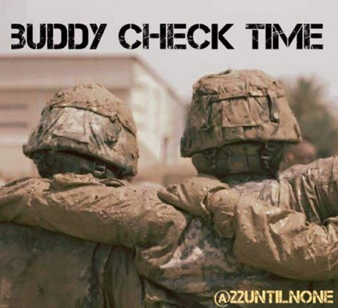
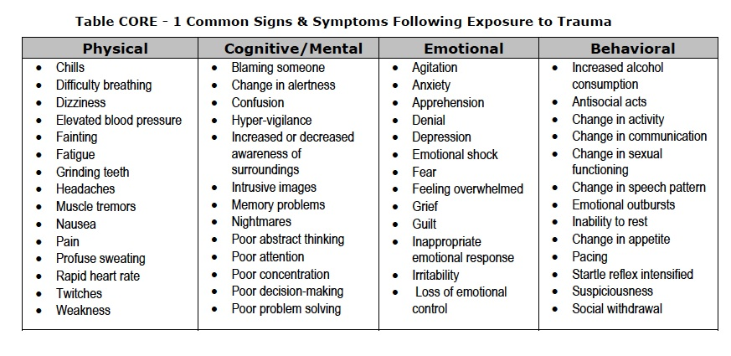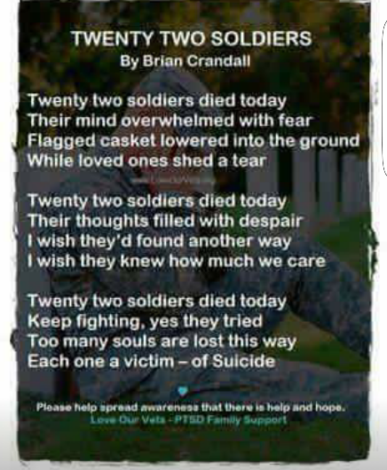

(This is real problem. We have 22 veterans that commit suicide a day. We need to do our best to help prevent one in becoming 1 of the 22. Call, text or message then on Facebook. If you one that does suffer from PTSD like I do talk to someone it helps whether it is a friend or therapist.)
Maggie Rogers

Commandant
Chris Holzworth holzworths@bellsouth.net
850-463-2494

Senior Vice Commandant Robert Fernandez w5.usmc@gmail.com
850-995-7014

Junior Vice Commandant
Chuck Miller
avavball@aol.com
850-712-8380

Judge Advocate
Fitz

850-380-3478

Adjutant/Newsletter
Maggie Rogers teachothers@aol.com
562-964-8702

Paymaster
Ben Sandoval bensand48@hotmail.com 850-572-0554

Admin Officer (S-1)
JoAnn Lee
joannlee1983@gmail.com
850-7917089

Logistics Officer (S-4)
Kaci Sloan
mrsalismom@gmail.com
850-400-0165

Ops Officer (S-3)
Kenneth Morrow
good2015year@gmail.com
850-288-1097

Sgt. At Arms

Hiram Johnson

850-453-4521

Chaplain/Visitation Chairperson
William Broach
jet727@gulfeg.com
251-961-7272

Public Affairs Officer
Ed Rouse erousecpa@bellsouth.net
850-393-3507

Webmaster (S-6)
Ralph Koeniger
ralphkoeniger@att.net
850-725-0034

Yearly Dues

For members who pay their dues annually the dues are now $45 for renewals and $52 for new members. The
$52 includes the cost of the name tag.

New Members

There is a change in procedure for new members in that they will receive a membership packet when they provide a copy of their DD214. Then they will be sworn in at the following monthly meeting.

Life Membership Dues
AGE GROUP As of JAN. 2014 0 - 35 $500
36 - 50 $400
51 - 64 $300
65 - Over $200

PSD ID Card Processing Hours and Information
ID CARDS and DEERS ISSUES are handled between 0730 HRS and 1600 HRS, Monday through Friday.
The Customer Line may be tagged prior to 1600 hrs to accommodate the volume of customers.

Ship’s Store

Members wishing to purchase MCL merchandise, including covers, may do so by contacting the Marine Corps League Ship’s Store at 800-625-1775 or visit www.mcleague.org.

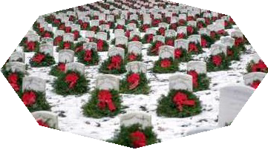 Wreaths Across America
Wreaths Across America accepts donations year around. Visit their website
http://www.wreaths-across-america.org/ for further information and consider making a donation to help them continue this outstanding program. The Young Marines are selling wreaths locally for $15 each.

If you require an ID card, you must have 2 forms of identification. In addition, military dependents must be accompanied by the sponsor or have Power of Attorney for the sponsor AND a DD1172 signed by the sponsor and an ID Verification Official. Please bring any required documentation needed for the requested service.

To assure that your ID CARD and DEERS issues are handled in a timely manner, it is suggested that you make an appointment at the following website:

http://appointments.cac.navy.mil Please contact our office if you have questions.
PSD Pensacola, Bldg 68o 421 Saufley Street, Suite B 850-452-3617

Businesses supporting the J.R. Spears Detachment of
the Marine Corps League
Detachment Member Owned Businesses
Steve Sanderson Automotive Alternative 6426 Pensacola Blvd.
Pensacola, FL 32505
850-857-1222

Earl Wright. Alarm Direct
850-776-7873
Smart Security and Surveillance Solutions

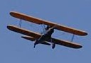
Roy M. Kinsey,Jr. Attorney at Law
438 E. Government St. Pensacola, Florida 32507
850-434-5267

Tom Armstrong More Ink For Less 120 Chief’s Way, Suite 1
Pensacola, FL 32507
850-455-1234

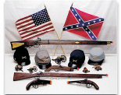
Del Lozano T&D Gallery of Gifts Pea Ridge Flea Market
5186 Hwy 90 Booth #33 & 34
850-450-7825

Ed Rouse

Ducker & Company
6825 Oak Street
Milton, FL 32570-0889
850-623-3250

Frenchy LaFountaine Ultra Marine Productions
9810 Indian Ford Rd. Milton, FL 32570
850-957-9069

Rhett Smith, P.A. Attorney at Law
714 N. Spring Street Pensacola, Florida 32501
850-438-1220

Community Owned Businesses

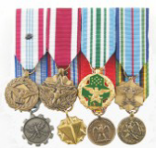
Medals to Honor, Inc. “Honoring Those Who Serve” www.MedalsToHonor.com
910-326-4275

BK Inflatables, Inc.
Let Us Inflate Your Next Party
850-324-1812

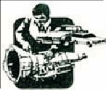
Hirst Transmission Specialist
8415 N. Palafox St. Ensley, FL 32534
850-478-3395

Petrick Custom Cabinets
Free Estimates 850-492-5480

Cantonment Building Materials & Hardware
990 Hwy 29 North Cantonment, FL 32533 850-968-6639

