BUNKER
TALK
Corps

  - Spears Detachment #066 Pensacola, FL
Founded January 19th, 1984 by William D. Carter
God Country
MEETING
Date/Time:
2nd Tuesday of each month at 1900
Location:
Florida National Guard Armory
8790 Grow Dr. in the Ellison Park Industrial

Contact Us:
J.R. Spears Det. 066 Marine Corps League
P.O. Box 3491 Milton, FL 32572 850-637-8385 Website:
http://pensacolamcleague.com

October 2016

22 Pushups for 22 Days
by
Maggie Rogers
A few of you know that I have been doing 22 pushups a day to bring awarness to PTSD and 22 vets committing sucide a day . The Commandant and Kaci Sloan and her daughter, Ali also joined in. If you are willing to join in please do so.
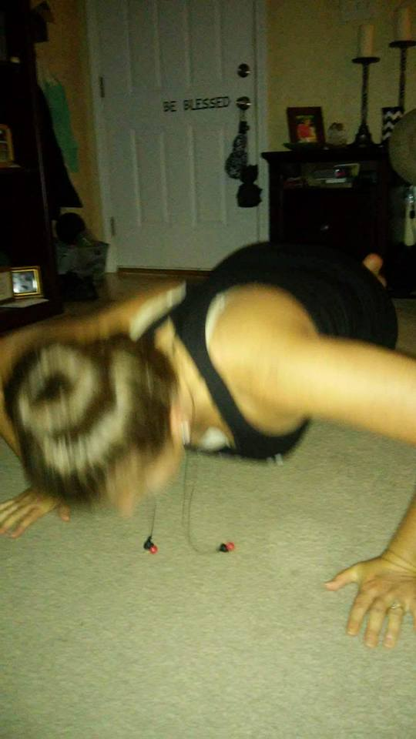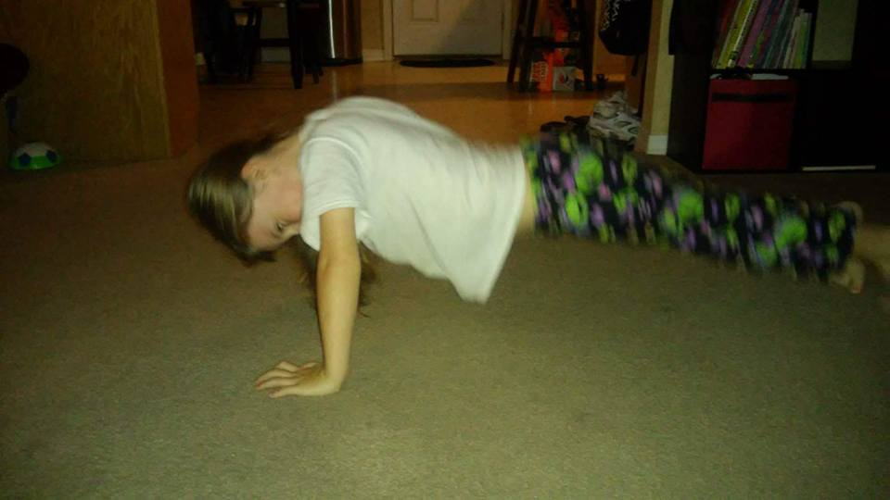

ICYMI: Military bomb tech suicides at crisis level
Melissa Nelson Gabriel , mnelsongab@pnj.com 5:32 a.m. CDT September 19, 2016

The numbers of invisible injuries are unknown at this point, and the suicide rate numbers are quickly approaching the numbers lost in combat
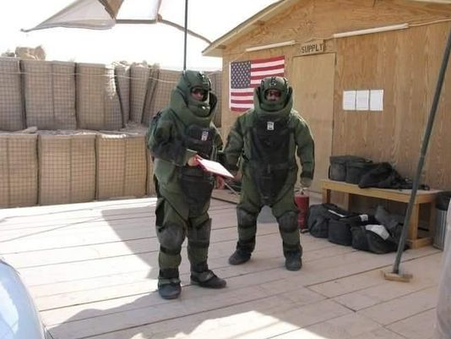
EOD technician Maj. Jeff Hackett, right, on deployment. Although he saved many lives, Hackett had issues dealing with the deaths of 16 colleagues and committed suicide in June 2010.(Photo: Special to the News Journal)
Danelle Hackett wanted her Marine husband to focus on the lives he saved disarming IEDs as a military bomb technician during two tours in Iraq.
Maj. Jeff Hackett could only focus on his 16 colleagues who died during the dangerous bomb disposal missions he led from early 2005 through late 2007. "My husband looked at those guys as his own family, his own sons. Repeatedly losing techs just wore on him and wore him. He blamed himself for every death," Danelle Hackett said.
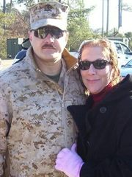
Maj. Jeff Hackett and his wife, Danelle. Danelle didn't know what to do to help her husband when he returned from his dangerous combat tours diffusing explosives. (Photo: Special to the News Journal)
In June 2010, after a day of drinking at an American Legion Post in Wyoming near the family's home, Jeff Hackett downed a couple more swigs of alcohol, said "cheers" and shot and killed himself.
Among the highly skilled and elite ranks of military explosive ordnance disposal technicians — the men and women who have been on the front line of the war on terror since Sept. 11, 2001 — suicide is a growing concern.
"It is literally an epidemic," said Ken Falke, a former EOD technician and founder of the Niceville-based EOD Warrior Foundation, which supports current and former military.
EOD technicians from all branches of the military graduate from the Navy's Explosive Ordnance Disposal School at Eglin Air Force Base. The school holds a moving memorial every spring and adds the names of graduates killed in combat during the previous year to its memorial wall. Since 9/11, 131 EOD technicians have died in combat and another 250 have sustained major physical injuries including lost eyesight, lost limbs, paralysis and major burns, but it is the numbers that aren't tallied that are now most alarming to Falke and many others.

One sentence at the bottom of every new release by the Warrior Foundation says it all: "The numbers of invisible injuries are unknown at this point and the suicide rate numbers are quickly approaching the numbers lost in combat."

Suicide is a major concern throughout the military and it is a special concern for the EOD Warrior Foundation, said Nicole Motsek, the foundation's director.

"We are a small community; we have only 7,000 people on active duty. During some months, it has been every week that we have lost someone. There are so many people out there with the invisible wounds of war and they are a part of our EOD community. We cannot wait and hope they get help, we have to do something now to help them," said Motsek, who is married to an Army EOD technician who has had multiple combat deployments.

The foundation plans a round-table summit in November to discuss suicide among EOD techs. The

foundation is also holding a retreat this fall for "White Star widows," the widows of EOD techs who have killed themselves.

The foundation does not have an exact number of EOD techs who have taken their own lives, in part because it is often difficult to tell if someone died accidentally or intentionally and also because there is not a good national tracking system. According to the latest information from the Veterans Administration, 20 veterans take their own lives each day, but that number only includes full reporting from 20 states. Air Force Sgt. Chris Ferrell, a 32-year-old EOD tech who has had many combat deployments to both Iraq and Afghanistan over the last 13 years, has attempted suicide four times.

He has a sleeve of tattoos on his arm with 26 shaded-in stars, each one represents a friend he has lost on the battlefield.

"Every one of them were killed by IEDs," he said. "For every IED you disarm, you save between one and 10 lives, but there is always another one you cannot take care of that gets hit. There becomes a point where it haunts your nightmares and it haunts your thoughts during the day."

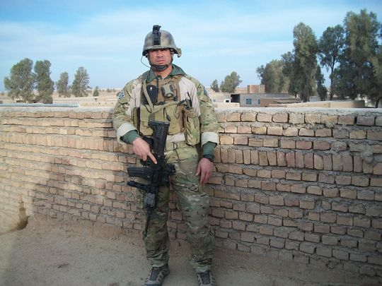

Air Force Sgt. Chris Ferrell has been deployed to both Iraq and Afghanistan many times over the last 13 years. He was just five feet away from his good friend, Sgt. Anthony Campbell Jr., when he was killed by an explosion. (Photo: Special to the News Journal)

Ferrell went for in-patient treatment at a military hospital where experts talked with him about his suicidal thoughts, but he said it was the thought of his three young children that motivated him to move forward.

"You have to find a purpose and new life," he said.

He now advises senior Air Force leadership about suicide prevention and awareness.

"There is a stigma about suicide, but we are getting better about making it more known," Ferrell said. "For the ones out there who are struggling (with suicidal thoughts) my message to them it is that you are definitively not alone, it does not have to be all on your shoulders."

Danelle Hackett didn't know what to do to help her husband when he returned from his combat tours.

"I could tell he was mess," she said.

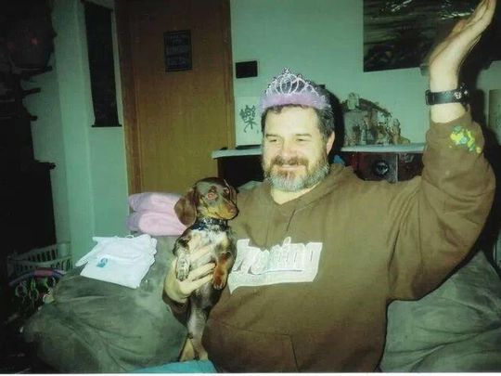
Maj. Jeff Hackett entertains his young granddaughter during the Christmas holidays. Hackett’s wife, Danelle, says he lost the laughter that he had always had after returning from his combat tours. (Photo: Danelle Hackett/Special to the News Journal)
Jeff Hackett began drinking heavily and getting into petty fights with his sons.
"He lost that laughter that he had always had. He was always such a funny guy and I was usually the butt of his jokes," said Hackett, who recalled her husband dancing around and laughing to the 1992 song "I'm Too Sexy."
During his first deployment to Iraq, he began sending his wife emails saying that he could no longer stand to look at himself. When he came home on leave he lost interest in things he once enjoyed like gardening and NASCAR.
"He wouldn't sleep for days. When I would get up in the mornings, I honestly never knew who I would be waking up to. We would tell him that he needed to go and talk to somebody and he would tell us that he didn't have problem, that we were the ones who had the problem," she said.
"He got really hateful at times with his words. He would drink the biggest bottle of Makers Mark in two days and he would act out in front of his family, he would berate the kids."
Danelle Hackett knew something was terribly wrong, but she didn't know what to do to help her husband. She said the military's policies made things worse because Jeff Hackett worried that if he sought treatment he would be pulled from duty and couldn't continue his vital work.
And Jeff Hackett could never let go of the deep sense of failure he felt about the people he could not save.
"He felt like he was bad for the (EOD) field, like he had messed up and let the field down because he wasn't able to bring home the ones who were killed. He felt that he was a huge let down to their families and the guys he lost. He felt like he was a failure no matter how hard I tried to tell him otherwise."
Four years after her husband's suicide, the couple's 24-year-old son, Drew, killed himself. Drew Hackett had been deeply troubled by his father's death, she said.
By speaking out about the deaths of her husband and her son, Danelle Hackett hopes to make a difference for another family.

"Nothing is going to be done about it unless we talk about it. There is such a stigma attached to suicide," she said.
Other EOD suicide deaths include a Navy captain and an Army colonel and other sailors, soldiers and airmen of all ranks and backgrounds, Falke said.
Part of the problem in addressing the issue is that EOD techs come from all branches of the military and often work with small special forces units — Ferrell and Campbell were deployed with a British special forces unit when Campbell was killed. The EOD techs train at the same school, but techs from the four military branches work independently and in small groups, he said.
The foundation's goal is to bring the entire EOD community together to focus attention on the issue.
THIS IS AN IMPORTANT ISSUE WHETHER IT IS PTSD OR VETERAN SUICIDE. We need to help when needed whether it is an ear or get them help. This just doesn’t happen to combat vets, it also effect woman that served.

Message from Lenny Collins

Just wanted to let everyone know that Gloria, is home. She had a rough time during the operation for her knee. They had to give her 2 pts. Of blood.
Her blood pressure was so low they had to keep watching her.
But she is a fighter. After 5 days in the hospital, and a wk. in rehab. She finally made it home. She has a therapist who comes 3x a wk. to learn how to walk right again but glad that she is home.
I want to thank the MCL for everyone's thoughtful concerns and help. Still not through hard times yet but we are making it. One step at a time. Gloria wanted to thank everyone s concerns.
Especially the phone calls.

HAU Night with Captain Rupert “Skeets” Fairfield
Local Vietnam War hero to be recognized at Heroes Among Us
Written by Melissa Nelson Gabriel , mnelsongab@pnj.com
Flying low over a North Vietnamese beach in a helicopter gunship, Marine Capt. Rupert "Skeets" Fairfield and three other Marines spotted four American soldiers tied to the ground while being bludgeoned and bayoneted by dozens of North Vietnamese soldiers.
The four Marines undertook a harrowing rescue that earned them the nation's highest military honors and became part of Marine Corps' lore.
The 77-year-old retired lieutenant colonel, who has rarely spoken publicly about the events that led to his being awarded the Navy Cross for valor, will recount the story Thursday night as the featured speaker at the Pensacola Marine Corps League's monthly outdoor speakers series in Veterans Memorial Park. Fairfield, who lives in Milton, agreed to share his story to help support the nonprofit's efforts to help area veterans and active duty military members.
Two other Marines on the 1967 rescue mission were recognized with the Navy Cross, and the Marine pilot, Marine Maj. Stephen W. Pless, received the Congressional Medal of Honor, the nation's highest military medal.
Fairfield said he and the other men on the UH-1E Huey gunship knew they would be outnumbered and might not survive the dangerous mission.
"It wasn't the kind of thing you could look at and leave," he said, recalling the site of the four soldiers tied to the ground, being beaten with rifle butts and sliced with bayonets.
Fairfield, who had recently begun his 13-month tour in Vietnam, was co-piloting the helicopter. The Marines were providing a routine security escort for a medical-evacuation helicopter when they got the radio distress call about an Army helicopter that had gone down nearby in enemy territory.
The gunship began a series of strafing maneuvers, flying low and targeting the North Vietnamese with machine guns and phosphorus rockets, he said.
The North Vietnamese would briefly retreat and then come back in larger numbers. The Marines didn't know it, but the beach was connected to an underground headquarters for the North Vietnamese and housed about 400 enemy troops.
"These guys were professionals and they just kept coming and coming," Fairfield said. "We fired all of the rockets and used most of the machine gun ammunition."
Pless landed the helicopter on the beach about 45 yards away from American soldiers. Fairfield and the other Marines then ran through muddy silt to reach the soldiers and try Fairfield reached another soldier whose throat had been slit. The man was dead. to carry them back to safety.
One soldier's arm had been cut to the bone by a bayonet.
"We handed him the machine gun and told him he would have to fire. I cannot imagine the pain," Fairfield said.
Fairfield reached another soldier whose throat had been slit. The man was dead.
"I was looking for his dog tags, but they had taken them," he said. The Marines had to leave the solider's body.
They carried two other severely wounded soldiers to the helicopter and attempted to take off, but their ordeal wasn't over. The helicopter wasn't designed for so much weight. Pless took the helicopter over the South China Sea to avoid enemy fire from the ground and the men began dumping items into the water to help gain altitude.
"We had plenty of stuff we could throw out the window, but we didn't want to throw anything out close to shore that (the enemy) could use. We had to wait until we were far enough out to start throwing the stuff," Fairfield said.
Two of the three rescued soldiers later died at a military hospital.
"At least they died on clean sheets and sedated," Fairfield said.
The career Marine recounted the story with little emotion, until he recalled not being able to find the dog tags on the slain American soldier. Fairfield stopped and choked up as he described his frantic search for the man's dog tags during the firefight.
"I got mad because they had taken his dog tags," said Fairfield, who said he wanted to at least be able to send the dog tags to the man's family.
In the five decades since the rescue mission, Fairfield has rebuffed attempts by others to label him a hero.
"The important thing to know is that we didn't do anything that any other Marine or Army helicopter guys wouldn't have done," he said.
But Fairfield's friend and fellow Marine pilot, Ret. Col. Steve Wilson, said Fairfield and the other men were heroes.
"It was undoubtedly the most-decorated flight in Vietnam and probably the most-decorated flight since that time," Wilson said. "There should have been four Medals of Honor and a lot of us believe that."
The Navy Cross is the second-highest military recognition for sailors and Marines after the Medal of Honor.
Pless, the Medal of Honor recipient, died in a motorcycle accident in 1969 in Pensacola.
Fairfield will speak at 6 p.m. at Veterans Memorial Park, 200 S. Ninth Ave. The Pensacola Marine Corps League created the popular speakers series to raise money for the nonprofit group's various projects that help veterans from all branches of the service.

Semper Fi 5k Run
Some of our members from the MCL run in the Semper Fi Run – Commandment, Ben Sandoval, and Major Morrow. I believe there was some others. Bob Rivera, he is a hard charger fist bumps or high five for when the runners came in.
There were younger runners all the way to two WWII veterans. OOHrah.

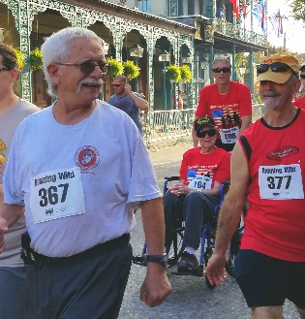
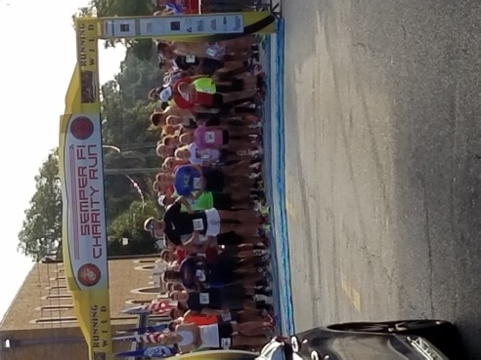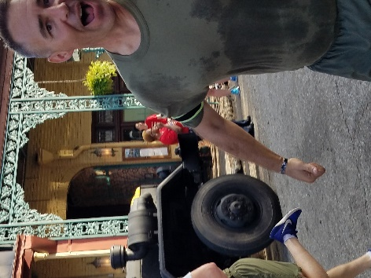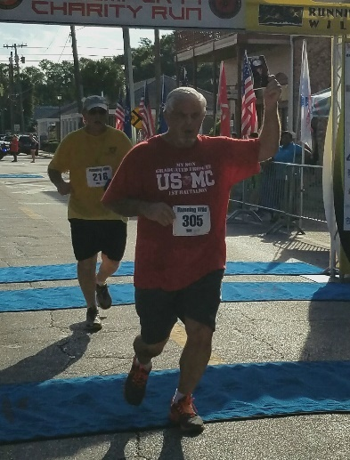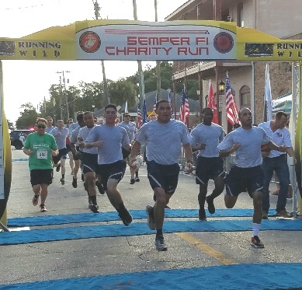
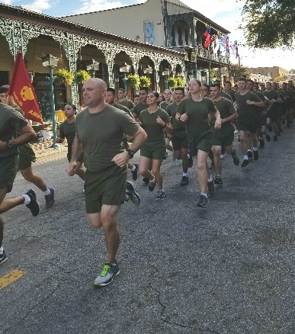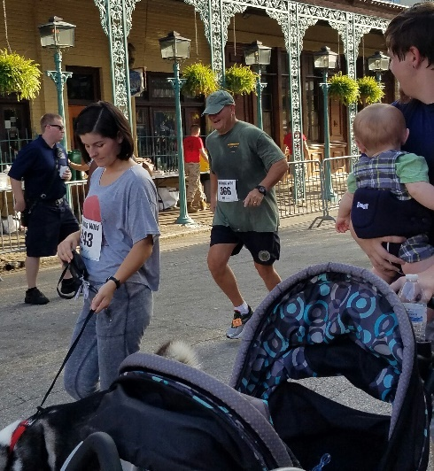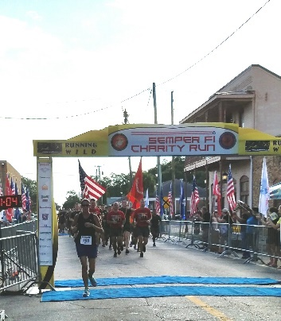

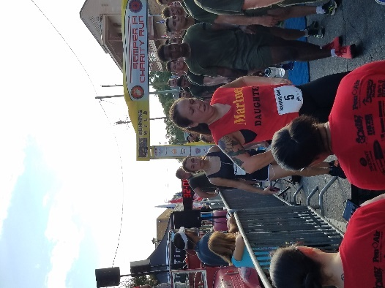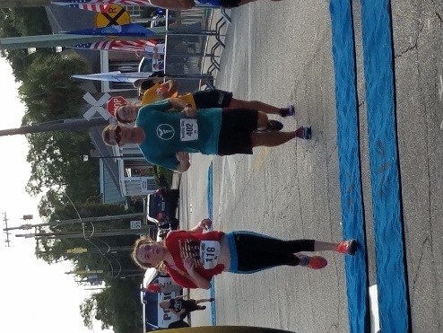
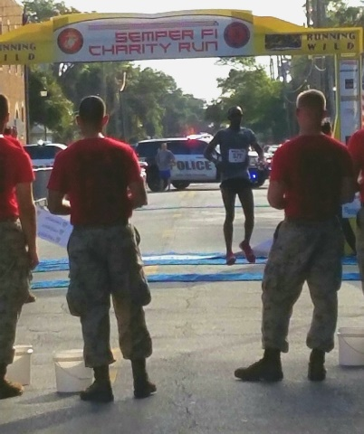

‬‬‬‬‬‬‬‬‬‬‬‬‬‬‬‬‬‬‬‬‬‬‬‬‬‬‬‬‬‬‬‬‬‬‬‬‬‬‬

A Message from the Commandant

Marine Corps Leaguers/Warriors of Detachment 66:

It has been a great year of Espirit de Corps and contribution to our Greater Pensacola community. Our "Award Winning" Heroes Among Us Speaker Series has kicked off the 4th season in grand style with record crowds and world class speakers-true heroes of our area and nation! We continue to meet the requests of local Veteran's who are in need with grants from the Veterans in Need Fund; our Service Division headed up by Doc Dodge has been doing outstanding work in supporting Veterans with their medical needs and VA claims. Recently, Tom Fitzgerald authored a point paper to MCL National to incorporate the Service Division into the Table of Organization of all MCL Detachments. Semper Fi Run on 10 September was a huge success with $20,000 being raised for local children's charities.

As we move into the Fall, let us all continue to support the great work of the League in the community as we finish our HAU season this year with two more great events in September and October. In addition, our MCL Marine Ball Celebration on 5 November with "H" Company 2/5 Vietnam reunion is sure to be a magnificent event. Lastly, 22 Oct is a Flagship event with the 16th Annual Car Show at Five Flags Speedway-please put this on your calendar.

Proud to be your Commandant-happy to be with Marines, Sailors, Soldiers, Airmen contributing to our community. I am proud to report our Detachment has soared to over 130 members from 77 a year ago and we are seeing greater numbers and veterans joining every meeting. Thanks to all for your servant's hearts.

Semper Fidelis,

Caveman

Commandant J. R. Spears Detachment, Pensacola, Florida

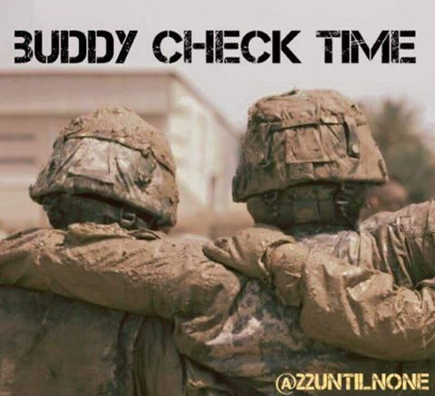
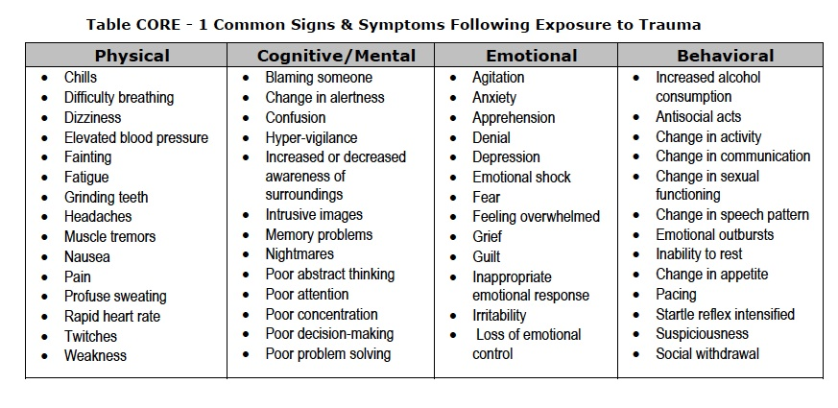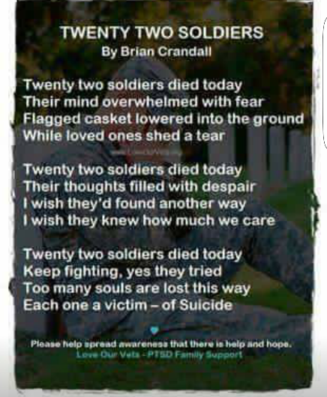

(This is real problem. We have 22 veterans that commit suicide a day. We need to do our best to help prevent one in becoming 1 of the 22. Call, text or message then on Facebook. If you one that does suffer from PTSD like I do talk to someone it helps whether it is a friend or therapist.)
Maggie Rogers

Commandant
Chris Holzworth holzworths@bellsouth.net
850-463-2494

Senior Vice Commandant Robert Fernandez w5.usmc@gmail.com
850-995-7014

Junior Vice Commandant
Chuck Miller
avavball@aol.com
850-712-8380

Judge Advocate
Fitz

850-380-3478

Adjutant/Newsletter
Maggie Rogers teachothers@aol.com
562-964-8702

Paymaster
Ben Sandoval bensand48@hotmail.com 850-572-0554

Admin Officer (S-1)
JoAnn Lee
joannlee1983@gmail.com
850-7917089

Logistics Officer (S-4)
Kaci Sloan
mrsalismom@gmail.com
850-400-0165

Ops Officer (S-3)
Kenneth Morrow
good2015year@gmail.com
850-288-1097

Sgt. At Arms

Hiram Johnson

850-453-4521

Chaplain/Visitation Chairperson
William Broach
jet727@gulfeg.com
251-961-7272

Public Affairs Officer
Ed Rouse erousecpa@bellsouth.net
850-393-3507

Webmaster (S-6)
Ralph Koeniger
ralphkoeniger@att.net
850-725-0034

Yearly Dues

For members who pay their dues annually the dues are now $45 for renewals and $52 for new members. The
$52 includes the cost of the name tag.

New Members

There is a change in procedure for new members in that they will receive a membership packet when they provide a copy of their DD214. Then they will be sworn in at the following monthly meeting.

Life Membership Dues
AGE GROUP As of JAN. 2014 0 - 35 $500
36 - 50 $400
51 - 64 $300
65 - Over $200

PSD ID Card Processing Hours and Information
ID CARDS and DEERS ISSUES are handled between 0730 HRS and 1600 HRS, Monday through Friday.
The Customer Line may be tagged prior to 1600 hrs to accommodate the volume of customers.

Ship’s Store

Members wishing to purchase MCL merchandise, including covers, may do so by contacting the Marine Corps League Ship’s Store at 800-625-1775 or visit www.mcleague.org.

Wreaths Across America
Wreaths Across America accepts donations year around. Visit their website
http://www.wreaths-across-america.org/ for further information and consider making a donation to help them continue this outstanding program. The Young Marines are selling wreaths locally for $15 each.

If you require an ID card, you must have 2 forms of identification. In addition, military dependents must be accompanied by the sponsor or have Power of Attorney for the sponsor AND a DD1172 signed by the sponsor and an ID Verification Official. Please bring any required documentation needed for the requested service.

To assure that your ID CARD and DEERS issues are handled in a timely manner, it is suggested that you make an appointment at the following website:

http://appointments.cac.navy.mil Please contact our office if you have questions.
PSD Pensacola, Bldg 68o 421 Saufley Street, Suite B 850-452-3617

Businesses supporting the J.R. Spears Detachment of
the Marine Corps League
Detachment Member Owned Businesses
Steve Sanderson Automotive Alternative 6426 Pensacola Blvd.
Pensacola, FL 32505
850-857-1222

Earl Wright. Alarm Direct
850-776-7873
Smart Security and Surveillance Solutions

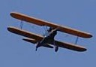
Roy M. Kinsey,Jr. Attorney at Law
438 E. Government St. Pensacola, Florida 32507
850-434-5267

Tom Armstrong More Ink For Less 120 Chief’s Way, Suite 1
Pensacola, FL 32507
850-455-1234

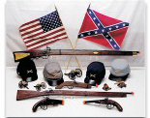
Del Lozano T&D Gallery of Gifts Pea Ridge Flea Market
5186 Hwy 90 Booth #33 & 34
850-450-7825

Ed Rouse

Ducker & Company
6825 Oak Street
Milton, FL 32570-0889
850-623-3250

Frenchy LaFountaine Ultra Marine Productions
9810 Indian Ford Rd. Milton, FL 32570
850-957-9069

Rhett Smith, P.A. Attorney at Law
714 N. Spring Street Pensacola, Florida 32501
850-438-1220

Community Owned Businesses

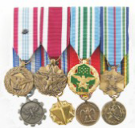
Medals to Honor, Inc. “Honoring Those Who Serve” www.MedalsToHonor.com
910-326-4275

BK Inflatables, Inc.
Let Us Inflate Your Next Party
850-324-1812

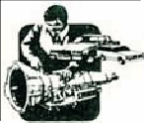
Hirst Transmission Specialist
8415 N. Palafox St. Ensley, FL 32534
850-478-3395

Petrick Custom Cabinets
Free Estimates 850-492-5480

Cantonment Building Materials & Hardware
990 Hwy 29 North Cantonment, FL 32533 850-968-6639

